
Goddard Space Flight Center
National Aeronautics and Space Administration

Core Flight Executive (cFE)

Flight Software Application Developers Guide

582-2007-001

October 29, 2019 (version 5.5)
Maureen O. Bartholomew, Code 582
David L. Kobe, the Hammers Company, Inc.

Anh D. Van, Code 582

Acknowledgements

This document was tailored from the SDO Flight Software Developers Guide and the ST5 Flight Software Developer’s Guide (authors Peter Kutt/CSC, Mark A. Walters, Code 582).

Requirements and recommendations for C coding standards follow the Flight Software Branch C Coding Standard.

Revision History

Revision Number | Release Date | Changes to Prior Revision | Approval
2.0 | 7/13/05 | Updated API changes contained in cfe2.0 | MOB
3.1 | 12/20/05 | Updated API section in order to be consistent with cFE 3.1 | MOB
3.2 | 2/14/06 | Updated section 2 for build 3.2 | MOB
3.2.1 | 3/1/06 | Added External Time functions and updated directory structure to match cFE build 3.2 | MOB
3.3 | 6/23/06 | Updated to include changes for build 3.3 | MOB
4.0 |  | Updated to reference OSAL (DCR 2318)  Updated CFE_SB_ValidateChecksum return value (DCR) 2317 | MOB
4.1 | 6/4/07 | Add document number  Added Time API CFE_TIME_GetClockInfo  Added Memory Pool Description  Added elf2cfetbl Utility Instructions | MOB
4.1 | 6/8/07 | Replaced Appendix A.2 – A.7 with Doxygen generated APIs | MOB
5.1 | 2/14/08 | Updated the template app documentation to reflect the correct implementation.
5.2 | 9/3/08 | Removed Appendix A (API specifications) since the cFE Doxygen generated documents covers this (and is generated by the code). Note that this whole document will eventually be incorporated into the cFE Doxygen documentation. | MOB
5.3 | 3/4/2009 | Added comment in memory pool section to refer to users guide | RJM, MOB
5.4 | 7/9/2014 | Removed incorrect bulletin section 11.1  Updated directory tree diagrams | SLS
5.5 | 10/29/2019 | Updated documentation to includes sample_app and other applicable changes. | AV

Table Of Contents

Acknowledgements 2
Revision History 2
1 Introduction 6
1.1 Scope 6
1.2 Background 6
1.3 Applicable Documents 7
1.4 Acronyms 8
1.5 Glossary of Terms 8
2 cFE Application Development Environment 11
2.1 Directory Tree 11
2.2 Header Files 15
3 cFE Deployment Environment 16
3.1 Assumed On-Board Directory Structure 16
RAM:/ 16
4 cFE Application Architecture 16
4.1 Application Model 16
4.1.1 “Software Only” Application 16
4.1.2 “Hardware Servicing” Application 17
4.1.3 Multi-threaded Applications 19
4.2 Best Practices 19
4.2.1 cFE Application Template 19
4.2.2 Avoid “Endian-ess” Dependencies 19
4.2.3 Avoid Inter-Task Dependencies 19
5 Executive Services Interface 20
5.1 Application Registration 20
5.2 Application Names and IDs 20
5.3 Child Task Control 20
5.4 Application Start-Up Types 21
5.5 Shared Libraries 21
5.6 Device Drivers 21
5.7 Obtaining OS and Platform Information 21
5.8 OS Queues, Semaphores and Mutexes 22
5.8.1 Queues 22
5.8.2 Binary Semaphores 22
5.8.3 Mutex Semaphores 23
5.9 Interrupt Handling 24
5.10 Exceptions 25
5.11 Floating Point Processor Exceptions 25
5.12 Memory Utilities 26
5.12.1 Memory Read/Write Functions 26
5.12.2 Critical Data Store 26
5.12.3 Standard CRC Calculations 29
5.13 File System Functions 29
5.13.1 Device Functions 30
5.13.2 Directory Functions 30
5.13.3 File Functions 30
5.14 System Log 30
5.15 Software Performance Analysis 31
While outside the scope of this documentation, an external post processing tool has been developed to calculate CPU utilization, trace interrupts, track task CPU usage. In addition, other external tools can ingest data and provides a graphical display of the software timing based on the markers. To use these tools, an entry/exit timing call to produce performance information is needed. 31
5.16 Memory Pool 31
6 Software Bus Interface 32
6.1 Software Bus Terminology 33
6.1.1 Software Bus Messages 33
6.1.2 Pipes 33
6.1.3 Routing of Software Bus Messages 34
6.2 Creating Software Bus Pipes 34
6.3 Software Bus Message Subscription 35
6.4 Unsubscribing from Receiving Software Bus Messages 36
6.5 Creating Software Bus Messages 37
6.5.1 Modifying Software Bus Message Header Information 38
6.6 Sending Software Bus Messages 39
6.7 Improving Message Transfer Performance for Large SB Messages 39
6.8 Receiving Software Bus Messages 41
6.8.1 Reading Software Bus Message Header Information 44
6.9 Deleting Software Bus Pipes 45
7 Event Service Interface 45
7.1 Event Messages 45
7.2 Event Types 46
7.3 Event Service Registration 46
7.3.1 Binary Filtering Scheme 47
} CFE_EVS_BinFilter_t 47
7.4 Sending an Event Message 49
7.4.1 Event Message Text 49
7.5 Event Service Un-registration 50
8 Table Service Interface 50
8.1 Table Terminology 50
8.1.1 Tables 50
8.1.2 Active vs. Inactive Tables 50
8.1.3 Single vs. Double Buffered Tables 51
8.1.4 Loading/Activating a Table 51
8.1.5 Dumping a Table 51
8.1.6 Validating a Table 51
8.2 Registering Tables 51
8.3 Accessing Table Data 53
8.3.1 Acquiring Table Data 53
8.3.2 Releasing Table Data 54
8.4 Managing a Table 54
8.4.1 Validating Table Data 54
8.4.2 Loading/Updating Table Data 55
8.4.3 Simplifying Table Management 56
8.5 Creating Table Image Files using the elf2cfetbl Utility 56
8.5.1 elf2cfetbl utility files 56
8.5.2 Creating an Executable of the elf2cfetbl Utility 57
8.5.3 Preparing a Source File for use with the elf2cfetbl Utility 57
8.5.4 Example of Table Data Source File 57
8.5.5 elf2cfetbl Utility Command Line Options 58
8.5.6 Converting COFF Object Files into ELF Object Files 59
9 File Service Interface 59
9.1 Standard File Header 59
9.2 Accessing and Modifying the Standard File Header 60
9.3 Other File Service Utility Functions 62
10 Time Service Interface 63
10.1 Time Formats 63
10.2 Time Values 63
10.3 Basic Time Functions 64
10.4 Time Conversion Functions 65
10.5 Time Manipulation Functions 65
11 Error Handling 68
11.1 Standard Error Codes 68
Appendix A 69

Introduction

Scope
The purpose of this document is to provide guidelines and conventions for flight code development using the Core Flight Executive (cFE) Application Programming Interface (API). These interfaces apply to C&DH, ACS and instrument control software; note that particular subsystems may need to follow specific software coding guidelines and standards in addition to using the functions provided within the cFE API.

These guidelines and conventions are specified with different weights. The weighting can be determined by the use of the following words:

- “Shall” or “must” designates the most important weighting level and are mandatory. Any deviations from these guidelines or conventions must have, at a minimum, the non-compliance documented fully and, at a maximum, require a project management waiver.
- “Should” designates guidelines that are determined to be good coding practice and are helpful for code maintenance, reuse, etc. Noncompliance with should statements does not require waivers nor additional documentation but appropriate comments in the code would be useful.
- “Could” designates the lowest weighting level. These could statements designate examples of an acceptable implementation but do not require the developer to follow the example precisely.

Background
The cFE provides a project-independent Flight Software (FSW) operational environment with a set of services that are the functional building blocks to create and host FSW Applications. The cFE is composed of six core services: Executive Service (ES), Software Bus Service (SB), Event Service (EVS), Table Service (TBL) and Time Service (TIME) (See Figure 1). Each cFE service defines an API that is available to the application as a library of functions.

It is important for application developers to realize the long term goal of the cFE. With a standard set of services providing a standard API, all applications developed with the cFE have an opportunity to become useful on future missions through code reuse. In order to achieve this goal, applications must be written with care to ensure that their code does not have dependencies on specific hardware, software or compilers. The cFE and the underlying generic operating system abstraction layer API (OSAL API) have been designed to insulate the cFE Application developer from hardware and software dependencies. The developer, however, must make the effort to identify the proper methods through the cFE and OSAL APIs to satisfy their software requirements and not be tempted to take a “short-cut” and accomplish their goal with a direct hardware or operating system software interface.

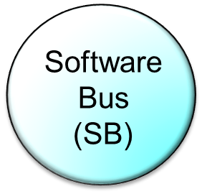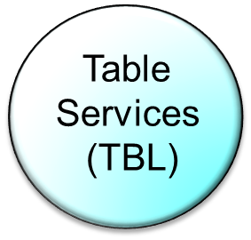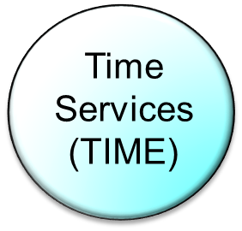

Figure 1: cFE Core Services

Applicable Documents
Location | Documents | Descriptions
https://github.com/nasa/osal/tree/master/doc | Osal Library API.doc | Describes OSAL API
https://github.com/nasa/cFE/tree/master/docs | cFE Application Developers Guide.doc | cFE developer’s guide. Contains best practice, various API informations and example implementation.
TBD | PSP API (TBD) | Describes PSP API

Acronyms
Acronym | Description
AC | Attitude Control
ACE | Attitude Control Electronics
ACS | Attitude Control System
API | Application Programming Interface
APID | CCSDS Application ID
BSP | Board Support Package
CCSDS | Consultative Committee for Space Data Systems
CDH, C&DH | Command and Data Handling
CDS | Critical Data Store
cFE | Core Flight Executive
cFS | Core Flight System
CM | Configuration Management
CMD | Command
CPU | Central Processing Unit
CRC | Cyclic Redundancy Check
EDAC | Error Detection and Correction
EEPROM | Electrically Erasable Programmable Read-Only Memory
ES | Executive Service
EVS | Event Service
FC | Function Code
FDC | Failure Detection and Correction
FSW | Flight Software
HW, H/W | Hardware
ICD | Interface Control Document
MET | Mission Elapsed Time
OS | Operating System
OSAL | Operating System Abstraction Layer
PID | Pipeline ID
PKT | Packet
QoS | Quality of Service
RAM | Random-Access Memory
SB | Software Bus
SDO | Solar Dynamics Observatory
ST5 | Space Technology Five
STCF | Spacecraft Time Correlation Factor
SW, S/W | Software
TAI | International Atomic Time
TBD | To Be Determined
TBL | Table
TID | Application ID
TLM | Telemetry
UTC | Coordinated Universal Time

Glossary of Terms
The following table defines the terms used throughout this document. These terms are identified as proper nouns and are capitalized.

Term | Definition
Application (APP) | A set of data and functions that is treated as a single entity by the cFE. cFE resources are allocated on a per-Application basis. Applications are made up of a Main Task and zero or more Child Tasks.
Application ID | A processor unique reference to an Application.  NOTE: This is different from a CCSDS Application ID which is referred to as an “APID.”
Application Programming  Interface (API) | A set of routines, protocols, and tools for building software applications
Board Support Package (BSP) | A collection of user-provided facilities that interface an OS and the cFE with a specific hardware platform. The BSP is responsible for hardware initialization.
Child Task | A separate thread of execution that is spawned by an Application’s Main Task.
Command | A SB Message defined by the receiving Application. Commands can originate from other onboard Applications or from the ground.
Core Flight Executive (cFE) | A runtime environment and a set of services for hosting FSW Applications
Critical Data Store | A collection of data that is not modified by the OS or cFE following a Processor Reset.
Cyclic Redundancy Check | A polynomial based method for checking that a data set has remained unchanged from one time period to another.
Developer | Anyone who is coding a cFE Application.
Event Data | Data describing an Event that is supplied to the cFE Event Service. The cFE includes this data in an Event Message.
Event Filter | A numeric value (bit mask) used to determine how frequently to output an application Event Message defined by its Event ID (see definition of Event ID below).
Event Format Mode | Defines the Event Message Format downlink option: short or long. The short format is used when there is limited telemetry bandwidth and is binary. The long format is in ASCII and is used for logging to a Local Event Log and to an Event Message Port.
Event ID | A numeric literal used to uniquely name an Application event.
Event Message | A data item used to notify the user and/or an external Application of a significant event. Event Messages include a time-stamp of when the message was generated, a processor unique identifier, an Application ID, the Event Type (DEBUG,INFO,ERROR or CRITICAL), and Event Data. An Event Message can either be real-time or playback from a Local Event Log.
Event Message Counter | A count of the number of times a particular Event Message has been generated since a Reset or since the counter was cleared via a Command. The counter does not rollover so a user cannot lose the knowledge that an event had occurred.
Event Message Port | A display device that is used to display Event Messages in a test environment. The communications mechanism between the flight processor and the display device is platform defined.
Event Type | A classification of an Event Message such as informational, diagnostic, and critical. See Section 7.2 for a definition of these types.
FIFO | First In First Out - A storage device that implies the first entry in is the first entry out.
Hardware Platform | The target hardware that hosts the FSW.
Interface Control Document | A document that describes the software interface, in detail, to another piece of software or hardware.
I/O Data | Any data being written to and read from an I/O port. No structure is placed on the data and no distinction as to the type of I/O device. I/O data is defined separately from memory data because it has a separate API and it’s an optional interface of the cFE.
Local Event Log | An optional Critical Data Store containing Event Messages that are generated on the same processor on which it resides. One Local Event Log can be defined for each processor.
Log | A collection of data that an application stores that provides information to diagnose and debug FSW problems.
Main Task | The thread of execution that is started by the cFE when an Application is started.
Memory Data | Any data being written to and read from memory. No structure is placed on the data and no distinction as to the type of memory is made.
Message ID | An identifier that uniquely defines an SB message.
Mission | A particular implementation of cFE FSW for a specific satellite or set of satellites.
MMU | Memory Management Unit. A piece of hardware that manages virtual memory systems. It automatically translates addresses into physical addresses so that an application can be linked with one set of addresses but actually reside in a different part of memory.
MsgId-to-Pipe Limit | The maximum number of messages of a particular Message ID allowed on a Pipe at any time. When a MsgId-to-Pipe Limit is exceeded, it is considered an error and is sometimes referred to as a MsgId-to-Pipe Limit error.
Network | A connection between subsystems used for communication purposes.
Network Queue | A device that stores messages and controls the flow of SB Messages across a Network.
Operational Interface | The Command and Telemetry interface used to manage the cFE and/or Applications.
Operator | Anyone who is commanding the FSW and receiving the FSW telemetry.
Pipe | A FIFO device that is used by Application’s to receive SB Messages.
Pipe Depth | The numbers of SB Messages a Pipe is capable of storing.
Pipe Overflow | Occurs when an attempt is made to write to a Pipe that is completely full of SB Messages. The number of SB Messages a Pipe can hold is given by the Pipe Depth. When a Pipe overflows, it is considered an error and is sometimes referred to as a Pipe Overflow error
Platform | See “Hardware Platform” above.
Processor Reset | The processor resets via the execution of its reset instruction, assertion of its reset pin, or a watchdog timeout.
Power-on Reset | The processor initializes from a no-power state to a power-on state.
Quality of Service (QoS) | Quality of Service has 2 components, Priority and Reliability.
Request | The act of an Application invoking a cFE service that resides on the same processor as the Application. A “Request” may be implemented as either function calls or SB Message exchanges and is specified in this document.
Routing Information | Any information required to route SB Messages locally or remotely.
Software Bus | An inter-Application message-based communications system
SB Message | A message that is sent or received on the software bus.
Subscribe | The act of requesting future instances of an SB Message to be sent on a particular Pipe. A valid subscription alters the SB Routing Information.
System Log | Special “Event Message” log for events that occur when the Event Services are not available.
Telemetry | A SB Message defined by the sending Application that contains information regarding the state of the Application or the state of devices interfaced to the Application.
Unsubscribe | To request that an SB Message no longer be routed to a particular Pipe. Properly unsubscribing to an SB Message alters the SB Routing Information.
User | Anyone who interacts with the cFE in its operational state. A user can be a FSW developer, a FSW tester, a spacecraft tester, a spacecraft operator, or a FSW maintainer.

cFE Application Development Environment
The following section describes the details of the standard cFE development environment in which the Developer writes and integrates their Application code. Each Mission could have, for their own reasons, a variation on this standard.

Directory Tree
The following diagrams show the standard development and build directory tree or mission tree as it is often referred to. The purpose of each directory is described as a note under each folder.

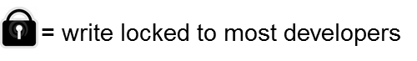

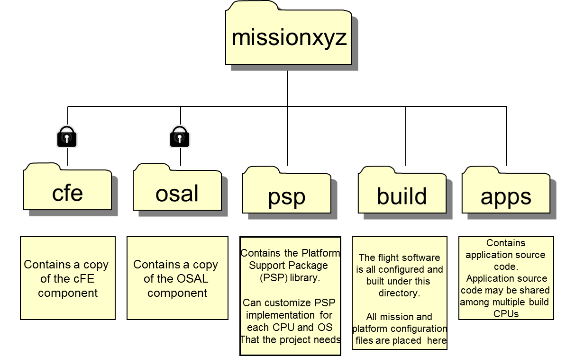

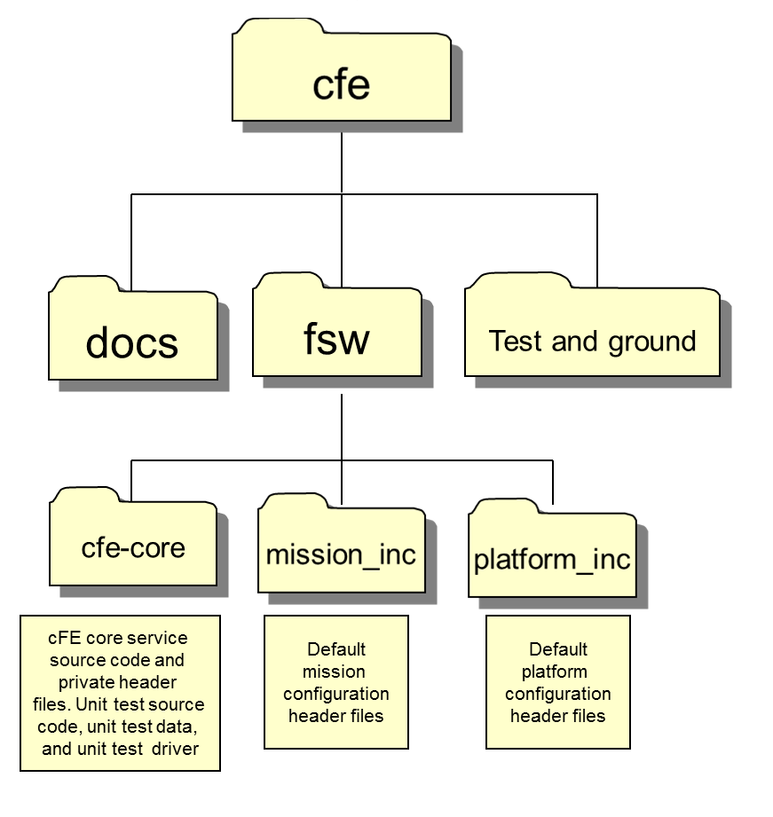

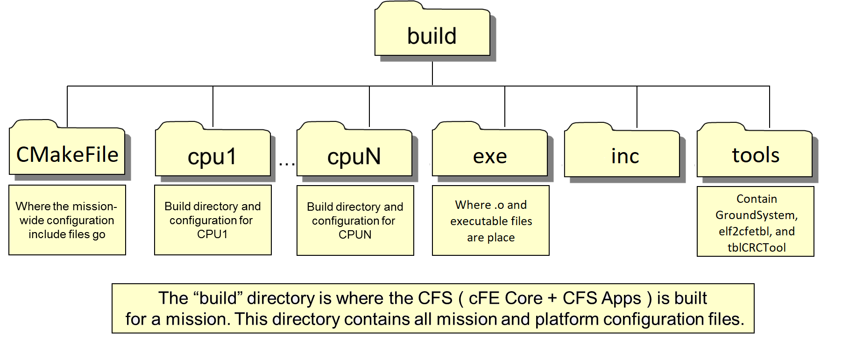

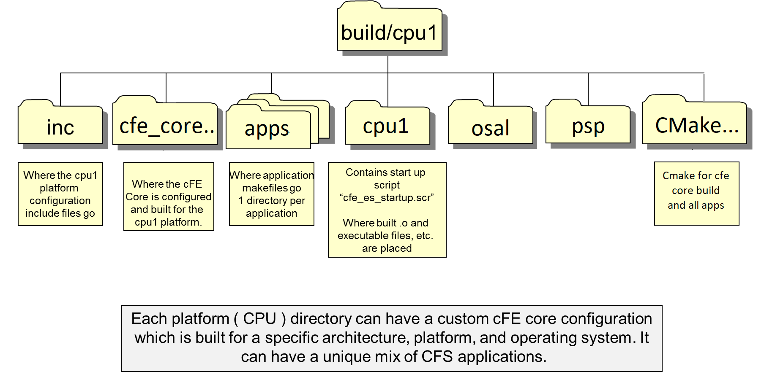

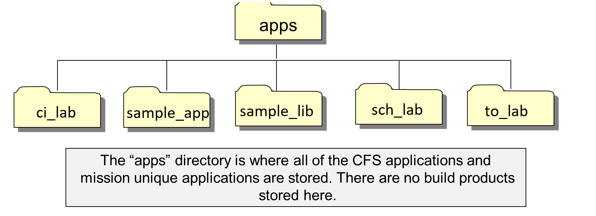
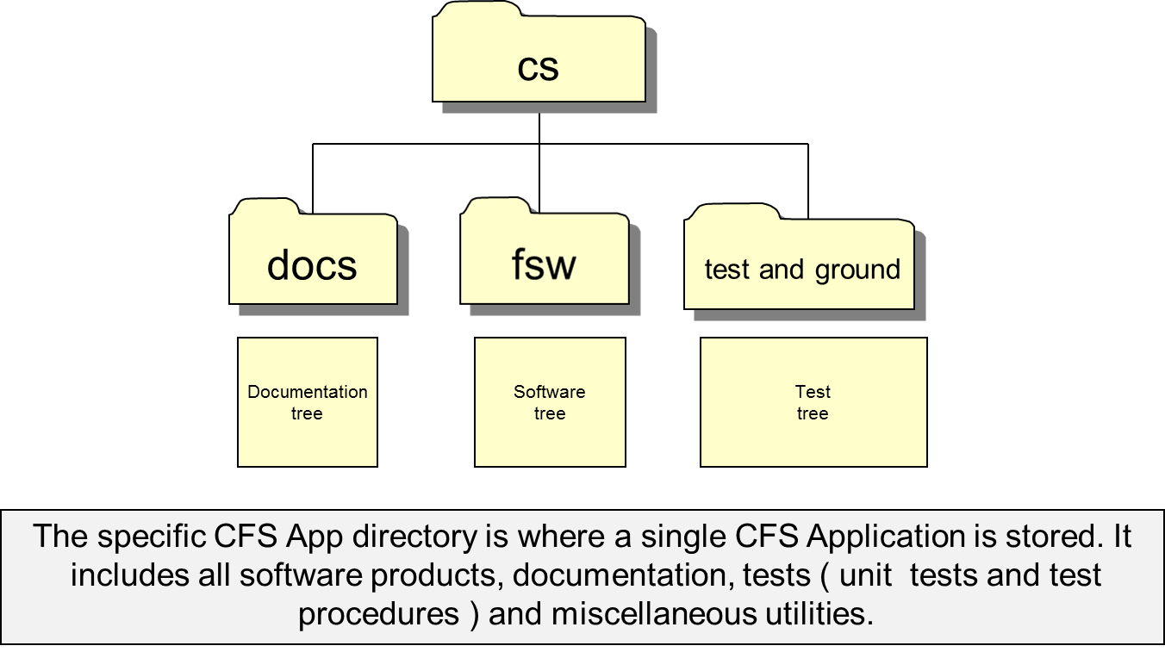

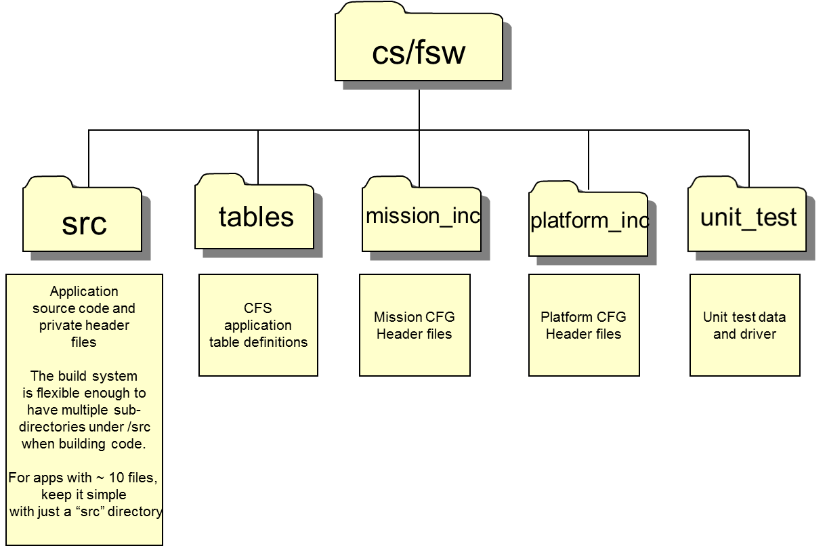

Header Files
In order for applications to use and call cFE service functions, the Developer must include the appropriate header files in their source code. The cFE can be easily incorporated by including the following line:

#include “cfe.h” /* Define cFE API prototypes and data types */

However, if the Developer is interested in viewing the API prototype declarations or data type definitions, they must look for them in the header file for the particular cFE Service. These header files are named as follows:

Filename | Contents
cfe_es.h | cFE Executive Service interface
cfe_evs.h | cFE Event Service Interface
cfe_fs.h | cFE File Service Interface
cfe_sb.h | cFE Software Bus Interface
cfe_tbl.h | cFE Table Service Interface
cfe_time.h | cFE Time Service Interface

All of these header files can be found in the “.../cfe-core/src/inc/” directory.

cFE Deployment Environment
The cFE core makes some assumptions about the target platform. Modifications to these assumptions would require modification to the cFE core source code.

  - Assumed On-Board Directory Structure
Portions of the cFE are capable of generating/overwriting files in response to commands (e.g. – log files, registry contents, etc). The cFE assumes that a specific file architecture is present when it generates these files. The file architecture and the expected contents are described in the diagram below.

RAM:/
RAM – the assumed name for the RAM disk.

cFE Application Architecture
In order to achieve the long term goals of the cFE, the Developer should structure their Applications with one of the following frameworks. Each of the frameworks described below has been designed to minimize code modification when the code is ported to either another platform and/or another mission.

  - Application Model

“Software Only” Application
A “Software Only” Application is a cFE Application that does not require communication with hardware directly. It is an Application that receives messages via the Software Bus, manipulates the data, and issues messages which are either telemetry or commands. Example of “Software Only” Application includes Store Command (SC) which encompass Absolute Time Command Processor (ATCP) and Relative Time Command Processor (RTCP).

A “Software Only” Application has the most promise of being reusable because it is insulated from most mission and platform specific characteristics. Therefore, the Developer must conform to the framework below to ensure maximum reusability in the future.

As seen in the following diagram, a “Software Only” application, shown here as either a “Reuse Application” or a “Mission Application,” should never talk directly with any piece of hardware or with the underlying operating system.

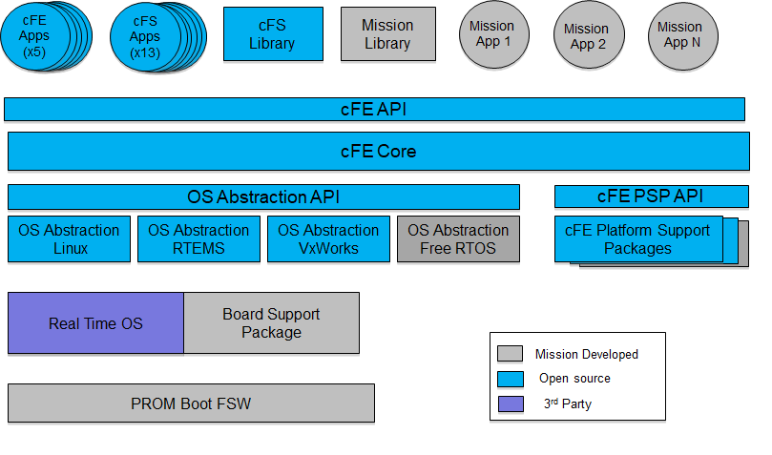

The Developer should ensure that all function calls to functions outside of the Application code are either to the cFE APIs or to the OS Abstraction Layer. Both of these are found in the Executive Layer.

“Hardware Servicing” Application
A “Hardware Servicing” Application is a cFE Application that is talking directly to a piece of hardware. This could be mission specific hardware, such as an experiment, or more common hardware, such as a receiver or transmitter. “Hardware Servicing” Applications should follow the Device Driver model as shown in the following diagram.

cFE Application
Hardware Device being serviced
cFE Executive Services
Register Driver Callback functions with Interrupt
cFE Generic Low Level Device ISR
cFE Interrupt Management Library
Device Initialization Function
Initialization
Call function to initialize hardware (intInitFuncPtr)
Hardware configured and initialized for operation
Device Handshaking Function (ISR Context)
Call function to perform any realtime processing or h/w handshaking (intHwHandshakingFuncPtr)
Perform realtime data processing and h/w handshaking
cFE Generic Device Processing Task
Device Initialization Function (Task Context)
Wakeup Task
Call function to perform any high level processing (intIsrFuncPtr)
cFE Software Bus, Events, etc.
Perform non-realtime data processing and h/w handshaking
Other cFE Service APIs
Task function is allowed to send messages, events, etc.

A “hardware servicing” Application first associates a set of three functions with a particular hardware interrupt via the cFE Executive Services device driver API. The first of the three functions performs any necessary hardware configuration and initialization. The second function runs within the ISR context whenever there is an interrupt generated by the hardware. This is useful for performing any realtime processing and hardware handshaking that must occur quickly and without interruption. Upon completion of the ISR function, the cFE notifies a device processing task that it created during the registration process that an interrupt occurred. This processing task calls the third callback function specified by the “hardware servicing” Application. This function, since it is running in a task context rather than an ISR context, is allowed full use of other cFE Service APIs. It is capable of sending messages, events, performing memory allocation, etc. For further details on this design, see section 5.6 and the device management API reference in Appendix A.

Multi-threaded Applications
The cFE supports the concept of multiple threads within an Application. Each thread is referred to as a Task. The first Task that executes when the Application is started is referred to as the Main Task. Any other Tasks that are spawned by the Main Task are called Child Tasks. When deciding on whether to create multiple Applications versus a single Application with multiple Tasks, the Application Developer should keep in mind these facts:

- Child Tasks can only execute at a priority equal to or less than the priority of the Application’s Main Task.
- If the Main Task of an Application is stopped, either through detection of an exception or via command, all Child Tasks are also stopped.

A multi-threaded model can be used in both “software only” and “hardware servicing” applications.

  - Best Practices

cFE Application Template
Applications designed to interface with the cFE should follow standard templates. Reference sample_app on Github for “live” example.

Files | Descriptions
fsw/src/sample_app.c | Main source code for sample_app. Located in src directory.
fsw/src/sample_app.h | Main header file for sample_app. It contains your main global typedef, prototypes, and miscellaneous define.
fsw/src/sample_app_events.h | Defines sample_app event IDs
fsw/src/sample_app_msg.h | Defines sample_app commands and its structures
fsw/tables/sample_table.c | Define sample_app table(s)
fsw/platform_inc/sample_app_msgids.h | Define sample_app message IDs
Fsw/mission_inc/sample_app_perfids.h | Define sample_app performace IDs

Avoid “Endian-ess” Dependencies
To ensure Application portability, Developers should be aware of code designs that can be affected by the “Endian-ess” of the processor. An example of where this could be a problem is in those situations where it is necessary to extract multi-byte data types from a stream of bytes. When this occurs, the Developer should ensure that if the source of the stream were to change from little-endian to big-endian or vice-versa, that the extraction would be successful. In a worse case situation, this may require the use of compiler switches based upon a platform’s endian setting to include the appropriate code.

Another common problem is in telemetry formatting. Frequently a telemetry packet is defined as a data structure of a variety of data types. Clearly, if the code is ported from a little-endian machine to a big-endian machine or vice-versa, the ground system telemetry database would be required to change.

Message ID

Application specific Event Message IDs. Because these numbers are combined with the cFE Application ID, the cFE ensures that every Event Message in a system is unique.

Application specific command codes. NOOP and RESET are required for all cFE Applications.

Application specific data structures specifying the content of command messages. Pointers to these data types can be used to access data from a received command message.

It is important to note that headers are declared as byte arrays. This is because the cFE does not require a specific header format. If Applications need to obtain information from the message header, it shall get it using Software Bus Library routines that extract the information for them.

Application specific data structures specifying the content of telemetry messages. Pointers to these data types can be used to store data before sending the structure as a Software Bus message. A Command Counter and Command Error Counter are required for all cFE Applications.

Application specific data structures specifying the content of the tables.

Full path specification of the files that contains the initial table values

Return values from the table validation function(s)

Organizing a tasks data into a single data structure will ensure that all of the data will be contiguous in memory. This is helpful when the target platform uses memory protection and/or an MMU and also for software maintenance.

A section defining all of the function prototypes.

The Application’s Main function. All Applications must provide a “TaskMain” function that represents their entry point.

The first step is App Registration which allows cFE to map the Task to various Executive Service resources and Operating System resources.

Next, a Task must initialize itself. The type of initialization can be determined through Executive Service API calls.

The Application then enters a continuous loop that obtains Software Bus Messages from its pipe(s) and performs the appropriate process on the received data/commands.

SB Messages that this Application generates must be initialized so that they contain appropriate header information and are formatted properly.

Applications must request the cFE to create their Software Bus pipes.

cFE Applications must inform cFE which SB Messages they expect to receive and on which pipe. This is referred to as a SB Message Subscription.

cFE Applications must register their tables with the cFE. The appropriate validation function for each table is included as part of the registration. Following registration, tables must be initialized, either from a file or from memory.

Process command by validating package length

Sending an SB Message to the cFE is essentially a three step process. First, the contents of the message are stored in a data structure that has been initialized. Second, the Message is time stamped with the appropriate mission time stamp, and finally, the Message is given to the Software Bus for routing to subscribers pipes.

Owners of each table must perform a periodic check for table updates for validation requests. The simplest method is to use the CFE_TBL_Mange function.

Processing received command messages are typically done in three steps. The first step is validation of the command. In these examples, this is accomplished by checking to see if the packet length matches the expected packet length (See SAMPLE_ProcessGroundCommand). The second step is performing the action requested by the command. The last step is notification of the operator that the command has succeeded. In this example, this is accomplished with an Event Message.

Accessing table data requires a combination of GetAddress and ReleaseAddress. GetAddress allows the owner of the table (i.e. the Application that registered the table) or the Application that is sharing the table to access the table data. Applications must ReleaseAddress in order for Table Services to be able to manipulate the table.

A helper function that validates the length of a received command message. Note the use of Software Bus API calls to extract information from the SB Message header.

User defines table validation function.

Avoid Inter-Task Dependencies
The Developer must separate those items that represent interface controlled data structures and values from other aspects of their software into unique header files. These files are then available to other Applications at compile time and act as the ICD between two or more Applications. When an Application is modified, it should be the only Application that needs to be recompiled for a change unless the change affects the published interface to other Applications.

Examples of items that must be shared with other Applications include Message IDs and Message data structures. Examples of items that do not need to be shared with other Applications include Table IDs, Table data structures, Event IDs and Pipe IDs.

Executive Services Interface
As seen in the diagram in Section 4.1, the cFE Executive Services is a layer that incorporates the OS Abstraction Layer (OSAL). The OSAL API was originally developed with the intent to provide a common interface for all Applications regardless of which RTOS the Application was running on. The OSAL was also designed to have as small a footprint as possible so that it could be implemented on a wide range of processors. The cFE has been designed to take advantage of this OS Abstraction Layer to improve its portability from one RTOS to the next. Since the cFE provides additional Executive Services that are not available with a standard RTOS, it stands between the OSAL and the cFE Application. However, since duplicating the OSAL in the cFE would add an unnecessary level in many cases, the OSAL is also visible to cFE Applications. Therefore, a developer needs to be cognizant that some of the API calls will either start with “CFE_”, because they are a member of the cFE API, or they will start with “OS_” because they are a part of the OS Abstraction Layer. If there are two functions that appear to behave similarly and one is an “OS_” function and the other is a “CFE_” function, the Developer should use the “CFE_” function. Additional information about the OSAL can be found in the OSAL Library API documentation.

  - Application Registration
All cFE Applications must register immediately with ES when started. This is accomplished with the CFE_ES_RegisterApp function and it should be the first function called by a cFE Application’s main task.

  - Application Names and IDs
The Executive Services maps Application names to numeric Application IDs. This simplifies the identification of Applications within the processor (by the numeric) but retains the human readable Application names for situations when the information is to be presented to an operator. Translating one reference of an Application to the other is accomplished with one of the following functions: CFE_ES_GetAppIDByName and CFE_ES_GetAppName. The first will return the numeric Application ID when given an Application name and the latter will give the Application name when given the Application ID. If a Task needs to obtain its own Application ID it can call CFE_ES_GetAppID. For this function, it is important to remember that an Application’s main task and all of its child tasks are considered to be the same Application. Therefore, no matter whether the call is made from the Main Task or one of the Child Tasks, the Application ID returned is the same.

  - Child Task Control
As mentioned in section 4.1.3, cFE Applications can be multi-threaded. Each thread is referred to as a Task. The thread that is started when the Application is loaded and run is referred to as the Main Task. Any additional threads that are spawned by this thread are referred to as Child Tasks. There are a handful of functions provided by the Executive Services for controlling Child Tasks. The first is CFE_ES_CreateChildTask. This function spawns a Child Task that is “owned” by the Main Task. Each of the Child Tasks must then register with ES via the CFE_ES_RegisterChildTask function. The remaining functions, CFE_ES_DeleteChildTask, CFE_ES_SuspendChildTask and CFE_ES_ResumeChildTask can control the existence and execution of the Child Task. All of these functions require the task ID that is returned by the CFE_ES_CreateChildTask function in order to identify the Child Task. Note that Child Tasks can only be created from the Main Task.

  - Application Start-Up Types
Upon startup, an Application may need to know which type of restart it is undergoing. As part of its initialization, an Application should call CFE_ES_GetResetType to determine the type of restart it is undergoing. The return value of this function can be any one of the following 2 values:

- CFE_PSP_RST_TYPE_POWERON

- CFE_PSP_RST_TYPE_PROCESSOR

Reference CFE API documentations.

  - Shared Libraries
The cFE contains support for shared libraries. For the current version of the cFE, the shared libraries must be loaded on cFE startup (see the cFE Deployment Guide on how to modify the cfe_es_startup.scr in order to load a shared library at startup). The capability to add and remove shared libraries during runtime will be available in a later build.

Reference Sample_lib on Github for “live” example.

Provides an entry point for the shared library. All shared libraries must have an init routine

  - Device Drivers

Reference “hardware libraries”.

  - Obtaining OS and Platform Information
There are numerous function related to obtaining OS and platform information. A number of these functions are not necessary for the cFE Application Developer. The functions that are the most useful to the Application Developer are as follows:

CFE_PSP_GetSpacecraftId returns an identifier associated with a specific spacecraft. This may be useful when the same software may be executing on multiple spacecraft as part of a multi-spacecraft mission.

CFE_PSP_GetProcessorId returns an identifier associated with a specific processor. This may be useful when the same software may be executing on multiple processors on the same spacecraft.

For understanding and compensating for the processor timer on a particular platform, the following two functions provide important information.

OS_Milli2Ticks converts a given number of milliseconds into the appropriate number of processor clock ticks for a given amount of time. The Developer should never hard-code a time related value in clock ticks. When the code is ported to another processor, it is important for any time values to automatically adjust appropriately.

OS_InfoGetTicks returns the number of microseconds per operating system clock tick. This can also be used to calculate the appropriate number of system clock ticks for a specific delta time. An example can be seen below:

uint32 ConvertSecs2Ticks(uint32 Seconds)
{
uint32 NumOfTicks,TickDurationInMicroSec;
TickDurationInMicroSec = OS_InfoGetTicks();
NumOfTicks =
( (Seconds * 1000000) + TickDurationInMicroSec - 1 ) / TickDurationInMicroSec;
return(NumOfTicks);
}

  - OS Queues, Semaphores and Mutexes

Queues
Developers are discouraged from using the OS_QueueCreate, OS_QueueDelete, OS_QueueGet and OS_QueuePut functions. These functions are a lower level duplication of the Software Bus Services pipes. Their usage limit the visibility into data messages being passed between Applications and they would also impose a requirement that two Applications must reside on the same processor. The only exception to this rule might be communication between a Main Task and its Child Tasks.

Binary Semaphores
Binary semaphores can be used for Application synchronization. A binary semaphore is essentially a flag that is available or unavailable. When an Application takes a binary semaphore, using the OS_BinSemTake function, the outcome depends on whether the semaphore is available or unavailable at the time of the call. If the semaphore is available, then the semaphore becomes unavailable and the Application continues executing immediately. If the semaphore is unavailable, the Application is put on a queue of blocked Applications and enters a pending state waiting for the availability of the semaphore.

When an Application gives a binary semaphore, using the OS_BinSemGive function, the outcome depends on whether the semaphore is available or unavailable at the time of the call. If the semaphore is already available, giving the semaphore has no effect at all. If the semaphore is unavailable and no Application is waiting to take it, then the semaphore becomes available. If the semaphore is unavailable and one or more Applications are pending on its availability, then the first Application in the queue of pending Applications is unblocked, and the semaphore is left unavailable.

Each semaphore is labeled by an integer ID, which is defined in the header file osids.h by a macro of the form xxx_SEM_ID. To add a new semaphore to a processor, one must modify the osids.h file and osobjtab.c file for the processor.

Binary Semaphore Functions
A binary semaphore can be created using the OS_BinSemCreate function. Upon success, the OS_BinSemCreate function sets the sem_id parameter to the ID of the newly-created resource. This ID is used in all other functions that use the binary semaphore.

int32 OS_BinSemCreate (uint32 *sem_id, const char *sem_name, uint32 sem_initial_value, uint32 options);

There are two options for pending on a semaphore:

int32 OS_BinSemTake( uint32 xxx_SEM_ID );

which waits indefinitely for a semaphore to become available, and

int32 OS_BinSemTimedWait( uint32 xxx_SEM_ID , uint32 timeout_in_milliseconds );

which waits for a specified timeout period and quits if the semaphore has not become available. Both functions return a status code with these possible values:

OS_SUCCESS — semaphore was obtained
OS_SEM_TIMEOUT — semaphore was not obtained within specified timeout
OS_SEM_FAILURE — error (such as invalid semaphore ID)

An application should always check the status code to verify that the semaphore was obtained.

A semaphore is given by using this function:

int32 OS_BinSemGive( uint32 xxx_SEM_ID );

The function returns a status code indicating success (OS_SUCCESS) or failure (OS_SEM_FAILURE). An application should check the status code and report a failure with an event message since the OS functions do not report errors themselves.

A semaphore is destroyed by using this function:

int32 OS_BinSemDelete (uint32 sem_id);

Mutex Semaphores
Mutex semaphores are used to provide “mutual exclusion” for a shared resource in order to protect against several Applications using the resource simultaneously. The major issue associated with sharing resources is priority inversion; the mutex semaphore provides a means for dealing with this problem.

A mutex semaphore is similar to a binary semaphore, but is used by Applications in a different way. When any Application needs to use a shared resource, it must follow a specific protocol:

Take the mutex, using OS_MutSemTake.
Use the resource.
Release the mutex, using OS_MutSemGive.

The operating system allows only one Application to hold the mutex at one time. If an Application tries to take a mutex that is not in use, then it acquires the mutex immediately. If the mutex is already in use, then the Application pends until the current holder of the mutex has released it.

The code that an Application executes between the Take and Give functions is said to be protected by the mutex. This code should be written in a structured way so that it is immediately clear what is being done in the protected region. The Take and Give functions should have the same level of indentation, and there should be exactly one entry point and one exit point to the protected region.

int32 OS_MutSemTake( uint32 xxx_MUT_ID );

/* protected region */
Use the resource...

int32 OS_MutSemGive( uint32 xxx_MUT_ID );

The code in the protected region should be kept as short as possible; any calculations that can be performed before entering the protected region should be done so. An Application should not hold a mutex any longer than necessary, since by doing so it may prevent a higher-priority Application from executing immediately. In particular, an Application should avoid performing any operations in the protected region that may cause the Application to pend, such as receiving a Software Bus packet, taking a semaphore, or taking another mutex. Any software design that involves pending in a protected region must be reviewed by the entire development group since it can affect the timing of the entire system.

Each mutex is labeled by an integer ID, which is defined in the header file osids.h by a macro of the form xxx_MUT_ID. To add a new mutex to a processor, one must modify the osids.h file and osobjtab.c file for the processor.

Mutex Functions
An application creates a mutex by calling:

int32 OS_MutSemCreate (uint32 *sem_id, const char *sem_name, uint32 options);
and deletes it by calling:

int32 OS_MutSemDelete (uint32 sem_id);

An application takes a mutex by calling:

int32 OS_MutSemTake( uint32 xxx_MUT_ID );

and gives it by calling:

int32 OS_MutSemGive( uint32 xxx_MUT_ID );

Both functions return a status code with these possible values:

OS_SUCCESS — semaphore was obtained
OS_MUT_FAILURE — error (such as invalid mutex ID)

There is no function for taking a mutex with a timeout limit since mutexes are assumed to be available within a short time.

  - Interrupt Handling
The following function specifies a handler for an interrupt. This is called in the initialization function for an interrupt handler.

OS_IntAttachHandler( uint32 InterruptNumber, void *InterruptHandler, int32 Param );

The possible values of InterruptNumber are defined in hardware-specific header files (osplatform.h and osprocessor.h). The InterruptHandler is a function that will be called when the interrupt is detected and should have a prototype that looks like the following:

void InterruptHandler( void );

The Param is a value that may be passed to the interrupt handler in some operating systems; it is currently not used and should be set to 0.

The interrupt handler must not invoke any cFE or OSAL function calls that could cause it to block.

The following functions can be used to enable and disable all interrupts. These should be used only when servicing a hardware device. For protecting a software variable against modification by several applications, one should use a mutex instead.

status = OS_IntEnableAll();
status = OS_IntDisableAll();

There are similar functions for enabling/disabling specific interrupts. These are OS_IntEnable and OS_IntDisable. These functions require an interrupt number to identify the interrupt to be enabled or disabled.

To acknowledge the interrupt has been serviced, the interrupt service routine must call OS_IntAck.

  - Exceptions
Similar to interrupt service routines, handlers can be associated with specific exceptions. The following function specifies a handler for an exception:

OS_ExcAttachHandler( uint32 ExceptionNumber, void *ExceptionHandler, int32 Param );

The ExceptionHandler is a function that will be called when the exception is detected and should have a prototype that looks like the following:

void ExceptionHandler( int32 Param );

There are addition functions for enabling/masking and disabling/unmasking specific exceptions. These are as follows:

OS_ExcEnable( uint32 ExceptionNumber );
OS_ExcDisable( uint32 ExceptionNumber );

  - Floating Point Processor Exceptions
In addition to the exception handlers identified above, a similar paradigm exists for handling floating point processor exceptions. The following function specifies a handler for an FPU exception:

OS_FPUExcAttachHandler( uint32 ExceptionNumber, void *ExceptionHandler, int32 Param );

The ExceptionHandler is a function that will be called when the exception is detected and should have a prototype that looks like the following:

void ExceptionHandler( int32 Param );

There are addition functions for enabling/masking and disabling/unmasking specific exceptions. These are as follows:

OS_FPUExcEnable( uint32 ExceptionNumber );
OS_FPUExcDisable( uint32 ExceptionNumber );

  - Memory Utilities

Memory utilities were deprecated after cFE 6.7, utilize built in memory functions (memcpy, memset, etc).

Memory Read/Write Functions
CFE provides a set of functions that read and write values of fixed sizes at specified physical addresses. These functions are intended for accessing hardware registers or memory devices with nonstandard properties. The EEPROM functions perform whatever operations are required for enabling the modification of EEPROM and then verify that the modification was successful.

Reference “PSP API Documentation”.

Critical Data Store
When an Application needs to store a small amount of data that will survive a cFE Reset, the cFE provides an area of memory called a Critical Data Store (CDS). This is an area of memory which, depending on mission parameters and the chosen platform, is not modified by the cFE during a reset. It could be memory located off-board, for example in the bulk memory device, or it may just be an area of memory that is left untouched by the cFE. In order to use the CDS, the Application must request a block of memory large enough to hold the parameters in question. This is accomplished by calling the CFE_ES_RegisterCDS. If sufficient memory is present, then the cFE will allocate the block to the calling Application and provide a pointer to the handle associated with the allocated memory.

The intention is for an Application to use a working copy of the CDS data during Application execution. Periodically, the Application is then responsible for calling CFE_ES_CopyToCDS API to copy the working image back into the CDS The cFE then computes a data integrity value for the block of data and stores it in the allocated CDS block. It should be noted that although the cFE will validate the integrity of the contents of the Application’s CDS, the Application is responsible for determining whether the contents of a CDS Block are still logically valid.

If the Application is recovering from a re-start and has discovered its CDS is still present, it can call an API to copy the contents of the CDS into a working image in the Application.

An example of how to use the CDS is shown below:

"sample_task.h":
/* Define the structure for the data stored in my Critical Data Store */
typedef struct
{
uint32 MyFirstDataPt; /* Variables that are stored in my CDS */
uint32 MySecDataPt;
.
.
.
} SAMPLE_MyCDSDataType_t;
typedef struct
{
.
.
.
CFE_ES_CDSHandle_t MyCDSHandle;/* Handle to CDS memory block */
SAMPLE_MyCDSDataType_t WorkingCriticalData; /* Define a copy of */
/* critical data that can be */
/* used during Application */
/* execution */
.
.
.
} SAMPLE_TaskData_t;
#define SAMPLE_CDS_NAME "CDS"

"sample_task.c":
SAMPLE_TaskData_t SAMPLE_TaskData;
int32 SAMPLE_TaskInit(void)
{
int32 Status = CFE_SUCCESS;
uint32 CDSCrc;
/* Create the Critical Data Store */
Status = CFE_ES_RegisterCDS(&SAMPLE_TaskData.MyCDSHandle,
sizeof(SAMPLE_MyCDSDataType_t),
SAMPLE_CDS_NAME);
if (Status == CFE_ES_CDS_ALREADY_EXISTS)
{
/* Critical Data Store already existed, we need to get a */
/* copy of its current contents to see if we can work use it */
Status = CFE_ES_RestoreFromCDS(&SAMPLE_MyCDSDataType_t, SAMPLE_TaskData.MyCDSHandle,
);
if (Status == CFE_SUCCESS)
{
/* Perform any logical verifications, if necessary, */
/* here to ensure the data is valid */
}
else
{
/* Perform baseline initialization */
SAMPLE_InitCriticalData();
}

Status = CFE_SUCCESS;
}
else if (Status == CFE_SUCCESS)
{
/* Perform baseline initialization */
SAMPLE_InitCriticalData();
}
else if (Status != CFE_SUCCESS)
{
/* Error creating my critical data store */
CFE_EVS_SendEvent(SAMPLE_CDS_ERR_EID, CFE_EVS_ERROR,
"Failed to create CDS (Err=0x%08x)", Status);
}
/* Perform common initialization here */
return Status;
}

void SAMPLE_TaskMain(void)
{
int32 Status = CFE_SUCCESS;
/*
** Enter performance log marker
*/
CFE_ES_PerfLogEntry(SAMPLE_MAIN_TASK_PERF_ID);
/*
** Register task
*/
CFE_ES_RegisterApp();
/*
** Perform task specific initialization
*/
Status = SAMPLE_TaskInit();
/*
** Main process loop (forever)
*/
while (Status >= CFE_SUCCESS)
{
CFE_ES_PerfLogExit(SAMPLE_MAIN_TASK_PERF_ID);
/*
** Wait for the next Software Bus message
*/
Status = CFE_SB_RcvMsg( &SAMPLE_TaskData.MsgPtr,
SAMPLE_TaskData.CmdPipe,
CFE_SB_PEND_FOREVER );
CFE_ES_PerfLogEntry(SAMPLE_MAIN_TASK_PERF_ID);
if (Status == CFE_SUCCESS)
{
/*
** Process Software Bus message
*/
SAMPLE_TaskPipe(CFE_TBL_TaskData.MsgPtr);
/* Update Critical Data Store */
CFE_ES_CopyToCDS(SAMPLE_TaskData.MyCDSHandle,
&SAMPLE_MyCDSDataType_t);
}
}
CFE_EVS_SendEvent(CFE_TBL_EXIT_ERR_EID, CFE_EVS_ERROR,
"SAMPLE Task terminating, err = 0x%X", Status);
} /* End of SAMPLE_TaskMain() */

Standard CRC Calculations
There are many Applications that require a validation of received data or of data in memory. This is usually done by a Cyclic Redundancy Check (CRC). There are many different ways to calculate a CRC. To help ensure that the calculation is done consistently for a mission, the Executive Services provides an API for a CRC calculation that can be used by all Applications on a mission. This function looks like the following:

uint32 CFE_ES_CalculateCRC(void *pData, uint32 DataLength, uint32 InputCRC, uint32 TypeCRC);
where pData points to the first byte of an array of bytes that are to have the CRC calculated on, DataLength specifies the number of sequential bytes to include in the calculation, InputCRC is the initial value of the CRC and TypeCRC identifies which of the standard CRC polynomials to be used. Currently, there are the following types available:

CFE_ES_CRC_8 – an 8-bit additive checksum calculation that returns a 32-bit value
CFE_ES_CRC_16 – a 16-bit additive checksum calculation that returns a 32-bit value
CFE_ES_CRC_32 – a 32-bit additive checksum calculation that returns a 32-bit value
CFE_ES_DEFAULT_CRC – the mission specified default CRC calculation

Unless there is a specific interface with a specified CRC calculation, Applications must use the CFE_ES_DEFAULT_CRC type.

  - File System Functions
The OSAL provides a POSIX.1 standard interface for performing file system activities. These functions break down into the following three categories: Device, Directory and File routines. Specific details of the API are not covered here. They can be found https://github.com/nasa/osal/

Device Functions
OSAL File System Function | Brief Description
OS_mkfs | Makes a file system on a specified device
OS_mount | Mounts a file system to make it accessible
OS_unmount | Unmounts a previously mounted file system
OS_chkfs | Checks file system to ensure links are correct

Directory Functions
OSAL File System Function | Brief Description
OS_mkdir | Makes a directory
OS_opendir | Opens a directory
OS_closedir | Closes a directory
OS_readdir | Reads a directory
OS_rewinddir | Resets a file pointer for a directory back to the beginning
OS_rmdir | Deletes a directory

File Functions
OSAL File System Function | Brief Description
OS_creat | Creates a file
OS_open | Opens a file
OS_close | Closes a file
OS_read | Reads a file
OS_write | Writes to a file
OS_chmod | Changes access rights to a file (may not be supported for an embedded system)
OS_stat | Obtains file statistics (time of last modification, size, etc)
OS_lseek | Moves the file pointer to a particular location in the file
OS_remove | Deletes a file
OS_rename | Renames a file

  - System Log
The Executive Services provide a System Log. A System Log provides a mechanism of recording Events that cannot be issued as Event Messages because the Event Service is either not running or is untrustworthy. An example of items that fall into this category are Events related to the boot process. Developer’s should make use of the Event Services CFE_EVS_SendEvent whenever possible. If, however, there is a significant Event that cannot be recorded using the CFE_EVS_SendEvent function, then the Developer can use the CFE_ES_WriteToSysLog function. This function has the following prototype:

int32 CFE_ES_WriteToSysLog(const char *pSpecString, ...);

The function acts just like a standard ‘C’ printf function and records the ASCII string to a buffer that is preserved during resets.

  - Software Performance Analysis

While outside the scope of this documentation, an external post processing tool has been developed to calculate CPU utilization, trace interrupts, track task CPU usage. In addition, other external tools can ingest data and provides a graphical display of the software timing based on the markers. To use these tools, an entry/exit timing call to produce performance information is needed.

  - Memory Pool
The Executive Services mempool library provides simple block memory management API’s and functions for pseudo dynamic memory allocations similar to malloc and dealloc. These functions allow applications to allocate memory blocks of variable size and return them to a memory pool for use by other application functions without the drawback of memory fragmentation. It is important to note that the mempool functions only manage a block of memory provided to it by the application; mempool does not create the block itself. Because of this, the application must ensure that sufficient memory is provided to store the mempool management structures in addition to the memory needed by the application. After initialization, mempool allocates fixed-size blocks as requested from the application memory block. As each block is requested mempool creates a 12 byte block descriptor with management structures as well as space for the user application data (see Figure 5.1). The space for user data will be fixed in size and greater than or equal to the requested block size. For example, if the application requests 60 bytes, mempool will return a pointer
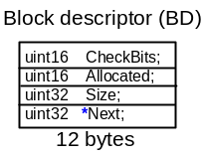
Figure 5.1 Block Descriptor

to the 64 user accessible bytes with the 12 byte descriptor “hidden” on the front for a total memory allocation of 72 bytes. All of this memory is allocated from the application pool. Once this memory is allocated it can only be used again for application requests of 64 bytes or less. It cannot be combined with other blocks to create larger memory allocations.

With the call to CFE_ES_PoolCreate, mempool takes the memory block allocated by the application and creates an management data structure as shown in Figure 5.2 starting at the address of the provided block. This memory is not available to user applications. As an initialization check, mempool requires that the provided application block contain enough space for one 168 byte management structure plus one 12 byte descriptor plus the smallest fixed size block (8 bytes). This constraint allows mempool to create at least one user application block.

Once this structure is created the application can use the CFE_ES_GetPoolBuf and CFE_ES_PutPoolBuf calls to allocate and de-allocate the memory blocks.

For additional design and user information related to the memory pool, refer to the cFE ES Users Guide.

Figure 5.2 shows an example set of structures for a pool of 2048 bytes and the allocation and deallocation of one request for 12 bytes.

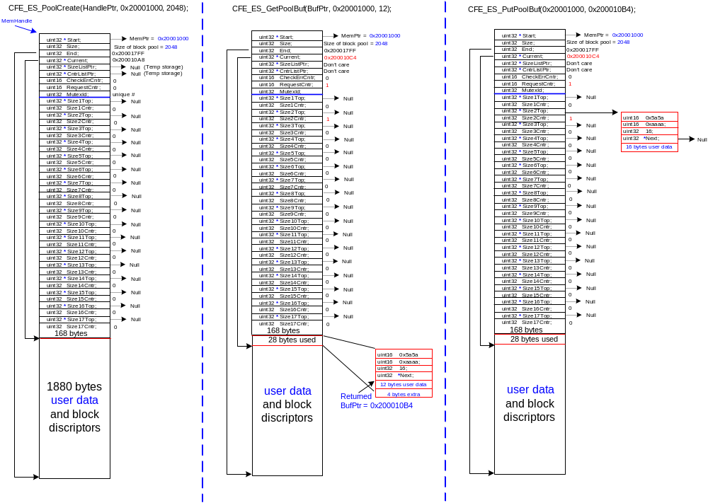
Figure 5-2 Example mempool allocations

Software Bus Interface
The Software Bus (SB) is an inter-application message-based communications system. The main objective of the SB is to provide a mechanism that allows subsystems to send packets without regard to where the packet is routed and to receive packets without the knowledge of where the packet came from. The SB uses a message-based subscription approach for establishing these communication paths. Any application may send an SB Message. The SB will route the SB Message to all applications that have subscribed to receive the SB Message. In order to receive an SB Message, an application must first create a Pipe on which to receive SB Messages.

The SB’s message-based subscription supports one-to-one, one-to-many, and many-to-one routing configurations. Multiple SB Message types can be routed to a single pipe. This is commonly done for applications that need to process ground commands.

The SB can also contain commands ingested from a flight interface, telemetry data to be sent out over a flight interface, or any other inter-application data. The flight interfaces for ingest and telemetry are typically managed by the Command Ingest (CI) and Telemetry Output (TO) applications, adapted as needed to fit the mission).

The SB provides different options for an application to check a pipe. Applications may Poll (non-blocking) a pipe to check if a SB Message is present or it may Pend (blocking) on a pipe and have its execution suspended until an SB Message arrives. An application may specify a Pend with timeout as well.

The SB supports inter-processor communications. From an application perspective, multi-processor communication is transparent.

  - Software Bus Terminology

Software Bus Messages
A Software Bus Message (SB Message) is a collection of data treated as a single entity. The format and the definition of the content is uniquely identified with a 16 bit Message ID. The Message ID is used to identify what the data is and who would like to receive it. Applications create SB Messages by allocating sufficient memory, calling the SB API to initialize the contents of the SB Message and then storing any appropriate data into the structure.

The Software Bus API hides the details of the message structure, providing routines such as CFE_SB_GetMsgTime and CFE_SB_SetMsgTime in order to get and set a message time. The current version of the cFE supports only CCSDS, however, the implementation of the message structure can be changed without affecting cFE Applications.

In the CCSDS implementation of the Software Bus, the upper 3 most significant bits of the 16 bit Message ID Number shall be zero (b’000’). The Software Bus ignores the upper 3 most significant bits defined by CCSDS as the Version Number. A non-zero value in the Version Number (3 bits) could result in duplicate Message IDs being defined. For example, x01FF and x81FF are the same Message ID to the Software Bus.

Pipes
The destinations to which SB Messages are sent are called pipes. These are queues that can hold SB Messages until they are read out and processed by an application. Each pipe can be read by only one application, but an application may read more than one pipe. Applications can wait (either indefinitely or with a timeout), or perform a simple check on their pipes to determine if an SB Message has arrived. Applications call the SB API to create their pipes and to access the data arriving on those pipes.

Every cFS application should have at least one pipe.

Software Bus Message Limits and Overflows
The SB software places a limit on how many SB Messages may be present at each pipe. The number of SB Messages at a pipe includes any SB Messages waiting in the pipe as well as the SB Message being processed by the application. If the limit is reached for a pipe, then additional SB Messages sent to that pipe are rejected (this is known as an overflow condition). However, SB Messages sent to other pipes continue to be processed normally. This is to prevent a slowly responding application from interfering with the routing of SB Messages to other applications.

The choice of buffer limits depends on the timing of both the sending and receiving applications.

Routing of Software Bus Messages
On a spacecraft using the cFE as the backbone of inter-Application communication, the routing of SB Messages between Applications occurs seamlessly, even between processors. The SB automatically notifies all other processors of SB Messages that the target processor wishes to receive. When applications send an SB Message to the SB, the SB searches its Routing Table to identify where the SB Message should be sent and performs the operations necessary to transfer the SB Message to the target pipe(s). Applications call the SB API to request specified SB Message IDs to be routed to their previously created pipes.

Sending Applications
Any software application is capable of sending SB Messages. However, interrupt and exception handlers shall not send SB Messages since the SB service uses operating system calls that may be prohibited (i.e. – they may be blocking calls) in such circumstances.

Receiving Applications
Any software application is capable of receiving SB messages. However, interrupt and exception handlers shall not receive packets since the SB software uses operating system calls that may be prohibited (i.e. – they may be blocking calls) in such circumstances.

An SB Message sent to a pipe is stored there until an application receives it (reads it out). SB Messages are received in the order that they were sent to the pipe. After an application receives an SB Message, it can process it as needed. The SB Message remains accessible to the application until the application starts to receive a new SB Message from the pipe, at which point the old SB Message is discarded.

Creating Software Bus Pipes
During the initialization of an Application, the Application must notify the cFE of pipes that it requires to receive data. The Application performs this request by calling the CFE_SB_CreatePipe API. The following is a brief example of how this is accomplished:

FILE: sample_app.h

...
/* Define Input Pipe Characteristics */
#define SAMPLE_PIPE_1_NAME “SAMPLE_PIPE_1”
#define SAMPLE_PIPE_1_DEPTH (10)
...

typedef struct
{
...
CFE_SB_PipeId_t SAMPLE_Pipe_1; /* Variable to hold Pipe ID (i.e.- Handle) */
...
} SAMPLE_AppData_t;

FILE: sample_app.c

SAMPLE_AppData_t; SAMPLE_AppData;
...

{
int32 Status;

...
Status = CFE_SB_CreatePipe( &SAMPLE_AppData.SAMPLE_Pipe_1, /* Variable to hold Pipe ID */
SAMPLE_PIPE_1_DEPTH, /* Depth of Pipe */
SAMPLE_PIPE_1_NAME); /* Name of Pipe */
...
}

In this example, the Developer has created a Pipe, called “SAMPLE_PIPE_1” with a depth of 10. The Pipe name shall be at least one character and no more than 15 characters long. Developers should prefix their Pipe names with the Application’s abbreviated name. Although the Pipe names will not collide with other Application Pipe names in the cFE, the Developer/Operator could become confused if every Application named their Pipe(s) “MY_PIPE”. It should be noted, however, that all Pipes for a single Application must have unique names.

The second parameter specifies the depth of the Pipe. The depth determines the maximum number of SB Messages that can be queued in the Pipe before an overrun condition occurs (see Section 6.1.2.1).

The first parameter returns the Pipe Identifier. This identifier is important when using other SB API functions. It is important to realize that the Pipe is not multi-thread safe. Therefore, it is illegal for another thread, even one from the same Application, to attempt to receive data from the created pipe. If multiple threads require access to messages, each thread needs to create their own pipe and make their own message subscriptions.

Software Bus Message Subscription
Once an Application has created a Pipe, it can begin to request data be put into that Pipe. This process is referred to a SB Message Subscription. An example of this process can be seen below:

FILE: app_msgids.h

...
/* Define Message IDs */
#define SAMPLE_CMDID_1 (0x0123)
...

FILE: sample_app.h

...
/* Define Receive Message ID Characteristics */
#define SAMPLE_CMDID_1_LIMIT (10)
...

typedef struct
{
...
CFE_SB_PipeId_t SAMPLE_Pipe_1; /* Variable to hold Pipe ID (i.e.- Handle) */
...
} SAMPLE_AppData_t;

FILE: sample_app.c

SAMPLE_AppData_t SAMPLE_AppData;

...
{
int32 Status;

...
Status = CFE_SB_SubscribeEX(SAMPLE_CMDID_1, /* Msg Id to Receive */
SAMPLE_AppData.SAMPLE_Pipe_1, /* Pipe Msg is to be Rcvd on */
CFE_SB_DEFAULT_QOS, /* Quality of Service */
SAMPLE_CMDID_1_LIMIT); /* Max Number to Queue */
...
}

In this example, the Application is requesting that all SB Messages whose ID is equal to 0x0123 be routed to the Pipe called “SAMPLE_PIPE_1” (see Section 6.2).

The third parameter specifies the desired Quality of Service (QoS). The Quality of Service determines the priority and the reliability of the specified SB Message that this particular Application requires. Most Applications will be satisfied with the default QoS, as defined with the CFE_SB_DEFAULT_QOS macro. Some Applications, such as an attitude control Application, may require a higher QoS to ensure receipt of critical sensor data. The current version of the cFE does NOT implement the QoS feature.

The fourth parameter specifies the limit on the number SB Messages with the specified Message ID that can be queued simultaneously in the specified Pipe. When messages with the specified Message ID are attempted to be queued in the specified Pipe and the limit has already been reached, it is referred to as an overrun condition. Note that this is a limitation on top of the Pipe depth which identifies the maximum number of all SB Messages combined that can be queued simultaneously. As mentioned previously, exceeding the Pipe depth is referred to as an overflow condition.

NOTE: SB Message IDs are defined in a separate header file from the rest of the Application’s interface. This makes it much simpler to port the Application to another mission where SB Message IDs may need to be renumbered.

Most Applications do not care about QoS nor the Message Limit hence those Applications can use the CFE_SB_Subscribe function. For those Applications that need to specify something other than the default QoS or Messages Limit, the SB API provides an additional function, CFE_SB_SubscribeEx that allows those parameters to be specified.

Unsubscribing from Receiving Software Bus Messages
If an Application no longer wishes to receive an SB Message that it had previously subscribed to, it can selectively unsubscribe to specified SB Message IDs. The following is a sample of the API to accomplish this:

FILE: sample_app.c

{
int32 Status;

...
Status = CFE_SB_Unsubscribe(SAMPLE_CMDID_1, /* Msg Id to Not Receive */
SAMPLE_AppData.SAMPLE_Pipe_1); /* Pipe Msg currently Rcvd on */
...
}

The first parameter identifies the SB Message ID that is to be unsubscribed and the second parameter identifies which Pipe the message is currently subscribed to.

Creating Software Bus Messages
For an Application to send a SB Message, it must first create it. The Application shall define the data structure of the SB Message, allocate memory for it (instantiate it), initialize it with the appropriate SB Message Header information and fill the rest of the structure with appropriate data. An example of this process can be seen below:

FILE: app_msgids.h

...
#define SAMPLE_HK_TLM_MID (0x0321) /* Define SB Message ID for SAMPLE’s HK Pkt */
...

FILE: sample_app.h

/*
** Type definition (SAMPLE task housekeeping)...
*/
typedef struct
{
uint8 TlmHeader[CFE_SB_TLM_HDR_SIZE];
/*
** Task command interface counters...
*/
uint8 CmdCounter;
uint8 ErrCounter;
} SAMPLE_HkPacket_t;
typedef struct
{
...
/*
** Task command interface counters...
*/
uint8 CmdCounter;
uint8 ErrCounter;
...
SAMPLE_HkPacket_t HkPacket; /* Declare instance of Housekeeping Packet */
...
} SAMPLE_AppData_t;

FILE: SAMPLE_app.c

SAMPLE_AppData_t SAMPLE_AppData; /* Instantiate Task Data */

...
{
int32 Status;

...
Status = CFE_SB_InitMsg(&SAMPLE_AppData.HkPacket, /* Address of SB Message Data Buffer */
SAMPLE_HK_TLM_MID, /* SB Message ID associated with Data */
sizeof(SAMPLE_HkPacket_t), /* Size of Buffer */
CFE_SB_CLEAR_DATA); /* Buffer should be cleared by cFE */
...
}

In this example, the Developer has allocated space for the SB Message header in their structure using the CFE_SB_TLM_HDR_SIZE macro. If the SB Message was to be a command message, it would have been important for the Developer to have used the CFE_SB_CMD_HDR_SIZE macro instead.

The CFE_SB_InitMsg API call formats the SB Message Header appropriately with the given SB Message ID, size and, in this case, clears the data portion of the SB Message (CFE_SB_CLEAR_DATA). Another option for the fourth parameter is CFE_SB_NO_CLEAR which would have retained the contents of the data structure and only updated the SB Message Header.

NOTE: SB Message IDs are defined in a separate header file from the rest of the Application’s interface. This makes it much simpler to port the Application to another mission where SB Message IDs may need to be renumbered.

Modifying Software Bus Message Header Information
Before sending an SB Message to the SB, the Application can update the SB Message Header. The most common update is to put the current time in the SB Message. This is accomplished with one of two SB API functions. The most commonly used function would be CFE_SB_TimeStampMsg(). This API would insert the current time, in the mission defined format with the mission defined epoch, into the SB Message Header. The other SB API that can modify the SB Message Header time is CFE_SB_SetMsgTime(). This API call sets the time in the SB Message Header to the time specified during the call. This is useful when the Application wishes to time tag a series of SB Messages with the same time.

Other fields of the SB Message Header can be modified by an Application prior to sending the SB Message. These fields, and the associated APIs, are listed in the following table:

SB Message Header Field | SB API for Modifying the Header Field
Message ID | CFE_SB_SetMsgId
Total Message Length | CFE_SB_SetTotalMsgLength
User Data Message Length | CFE_SB_SetUserDataLength
Command Code | CFE_SB_SetCmdCode
Checksum | CFE_SB_GenerateChecksum

Applications shall always use these functions to manipulate the SB Message Header. The structure of the SB Message Header may change from one deployment to the next. By using these functions, Applications are guaranteed to work regardless of the structure of the SB Message Header.

Sending Software Bus Messages
To send a SB Message, an application must first construct the SB Message in memory (see Section 6.5), set its contents to the appropriate values and then the application calls CFE_SB_SendMsg(). An example of this is shown below:

FILE: sample_app.c

SAMPLE_AppData_t SAMPLE_AppData; /* Instantiate Task Data */

...
{
...
/*
** Get command execution counters and put them into housekeeping SB Message
*/
SAMPLE_AppData.HkPacket.CmdCounter = SAMPLE_AppData.CmdCounter;
SAMPLE_AppData.HkPacket.ErrCounter = SAMPLE_AppData.ErrCounter;
/*
** Send housekeeping SB Message after time tagging it with current time
*/
CFE_SB_TimeStampMsg((CFE_SB_Msg_t *) &SAMPLE_AppData.HkPacket);
CFE_SB_SendMsg((CFE_SB_Msg_t *) &SAMPLE_AppData.HkPacket);
...
}
  - Improving Message Transfer Performance for Large SB Messages
Occasionally, there is a need for large quantities of data to be passed between Applications that are on the same processor (e.g.- Science data analysis and/or compression algorithms along with the science data acquisition Application). The drawback to using the standard communication protocol described above is that SB Messages are copied from the sending Application data space into the SB data space. If the copy is too time consuming, the Developer can choose to implement a “Zero Copy” protocol. Obviously, if the message is subscribed to on a different processor, the message is not “zero-copied” to those subscribers.

The first step in implementing the “Zero Copy” protocol, is to acquire a data space that can be shared between the two Applications. This is accomplished with the CFE_SB_ZeroCopyGetPtr API call. The CFE_SB_ZeroCopyGetPtr function returns a pointer to an area of memory that can contain the desired SB Message.

Once an Application has formatted and filled the SB Message with the appropriate data, the Application calls the CFE_SB_ZeroCopySend API. The SB then identifies the Application(s) that have subscribed to this data and places a pointer to the SB Message Buffer in their Pipe(s). The pointer to the SB Message is no longer valid once the Application calls the CFE_SB_ZeroCopySend API. Applications should not assume the SB Message Buffer pointer is accessible once the SB Message has been sent.

If an Application has called the CFE_SB_ZeroCopyGetPtr API call and then later determines that it is not going to send the SB Message, it shall free the allocated SB Message space by calling the CFE_SB_ZeroCopyReleasePtr API.

An example of the “Zero Copy” protocol is shown below:

FILE: app_msgids.h

...
#define SAMPLE_BIG_TLM_MID (0x0231) /* Define SB Message ID for SAMPLE’s Big Pkt */
...

FILE: sample_app.h

...
#define SAMPLE_BIGPKT_DATALEN (32768) /* Define Data Length for SAMPLE’s Big Pkt */
...
/*
** Type definition (SAMPLE task big packet)...
*/
typedef struct
{
uint8 TlmHeader[CFE_SB_TLM_HDR_SIZE];
/*
** Task command interface counters...
*/
uint8 Data[SAMPLE_BIGPKT_DATALEN];
} SAMPLE_BigPkt_t;
/* Define Msg Length for SAMPLE’s Big Pkt */
#define SAMPLE_BIGPKT_MSGLEN sizeof(SAMPLE_BigPkt_t)
...
typedef struct
{
...
...
SAMPLE_BigPkt_t *BigPktPtr; /* Declare instance of Big Packet */
...
} SAMPLE_AppData_t;

FILE: sample_app.c

SAMPLE_AppData_t SAMPLE_AppData; /* Instantiate Task Data */
...
{
...
/*
** Get a SB Message block of memory and initialize it
*/
SAMPLE_AppData.BigPktPtr = (SAMPLE_BigPkt_t *)CFE_SB_ZeroCopyGetPtr(SAMPLE_BIGPKT_MSGLEN);
CFE_SB_InitMsg((CFE_SB_Msg_t *) SAMPLE_AppData.BigPktPtr,
SAMPLE_BIG_TLM_MID,
SAMPLE_BIGPKT_MSGLEN,
CFE_SB_CLEAR_DATA);

/*
** ...Fill Packet with Data...
*/
/*
** Send SB Message after time tagging it with current time
*/
CFE_SB_TimeStampMsg((CFE_SB_Msg_t *) SAMPLE_AppData.BigPktPtr);
CFE_SB_ZeroCopySend((CFE_SB_Msg_t *) SAMPLE_AppData.BigPktPtr);
/* SAMPLE_AppData.BigPktPtr is no longer a valid pointer */
...
}
  - Receiving Software Bus Messages
To receive a SB Message, an application calls CFE_SB_RcvMsg as follows:

FILE: sample_app.h

typedef struct
{
...
CFE_SB_MsgPtr_t MsgPtr;
CFE_SB_PipeId_t CmdPipe;
...
} SAMPLE_AppData_t;

FILE: sample_app.c

{
...
while (TRUE)
{
/*
** Wait for the next Software Bus message...
*/
SB_Status = CFE_SB_RcvMsg(&SAMPLE_AppData.MsgPtr,
SAMPLE_AppData.CmdPipe,
CFE_SB_PEND_FOREVER);
if (SB_Status == CFE_SB_SUCCESS)
{
/*
** Process Software Bus message...
*/
SAMPLE_AppPipe(SAMPLE_AppData.MsgPtr);
}
}
}
In the above example, the Application will pend on the SAMPLE_AppData.CmdPipe until a SB Message arrives. A pointer to the next SB Message in the Pipe will be returned in SAMPLE_AppData.MsgPtr. The Application would then use SB Message Header accessor functions (as described in Section 6.8.1) to identify the message and typecast the pointer to an appropriate data structure.

The Application could have chosen to pend with a timeout (specified in milliseconds) as shown in the example below:

FILE: sample_app.h

...
#define SAMPLE_CMD_PIPE_TIMEOUT (20) /* Wait 20 milliseconds for a SB Message to arrive */
...

FILE: sample_app.c

{
...
while (TRUE)
{
/*
** Wait for the next Software Bus message...
*/
SB_Status = CFE_SB_RcvMsg(&SAMPLE_AppData.MsgPtr,
SAMPLE_AppData.CmdPipe,
CFE_SB_PEND_FOREVER);
if (SB_Status == CFE_SB_SUCCESS)
{
/*
** Process Software Bus message...
*/
SAMPLE_AppPipe(SAMPLE_AppData.MsgPtr);
}
else if (SB_Status == CFE_SB_TIME_OUT)
{
/*
** Process Late Data Arrival Case...
*/
}
}
}
If a SB Message fails to arrive within the specified timeout period, the cFE will return the CFE_SB_TIME_OUT status code.

The final method an Application could have chosen would be to quickly poll the Pipe to determine if a SB Message is present. This is shown in the following example:

FILE: sample_app.c

{
...
while (TRUE)
{
/*
** Check for the next Software Bus message...
*/
SB_Status = CFE_SB_RcvMsg(&SAMPLE_AppData.MsgPtr,
SAMPLE_AppData.CmdPipe,
CFE_SB_POLL); /* Just check to see if data is present */
if (SB_Status == CFE_SB_SUCCESS)
{
/*
** Process Software Bus message...
*/
SAMPLE_AppPipe(SAMPLE_AppData.MsgPtr);
}
else if (SB_Status == CFE_SB_NO_MESSAGE)
{
/*
** Process No Data Available Case...
*/
}
}
}
If the Pipe does not have any data present when the CFE_SB_RcvMsg API is called, the cFE will return a CFE_SB_NO_MESSAGE status code.

If the Application’s data structure definitions don’t include the header information, then the CFE_SB_GetUserData API could be used to obtain the start address of the SB Message data. An example of this can be seen below:

FILE: sample_app.h

#define SAMPLE_CMDID_WIDGET (0x4321)
...
typedef struct
{
uint16 Id;
uint16 NewMode;
} SAMPLE_WidgetCmdData_t;

...
typedef struct
{
...
CFE_SB_MsgPtr_t MsgPtr;
CFE_SB_PipeId_t CmdPipe;
...
SAMPLE_WidgetCmdData_t *WidgetCmdDataPtr;
...
} SAMPLE_AppData_t;

FILE: sample_app.c

{
...
while (TRUE)
{
/*
** Wait for the next Software Bus message...
*/
SB_Status = CFE_SB_RcvMsg(&SAMPLE_AppData.MsgPtr,
SAMPLE_AppData.CmdPipe,
CFE_SB_PEND_FOREVER);
if (SB_Status == CFE_SB_SUCCESS)
{
/*
** Check to make sure this is a Widget Command
*/
if (CFE_SB_GetMsgId(SAMPLE_AppData.MsgPtr) == SAMPLE_CMDID_WIDGET)
{
/*
** Typecast the user data portion to the Widget Cmd data structure type
*/
SAMPLE_AppData.WidgetCmdDataPtr =
(SAMPLE_WidgetCmdData_t *)CFE_SB_GetUserData(SAMPLE_AppData.MsgPtr);
}
}
}
}

Reading Software Bus Message Header Information
As mentioned earlier, since the SB Message Header is not always the same format, there are SB APIs available for extracting the SB Message Header Fields. These APIs shall always be used by Applications to ensure the Applications are portable to future missions. The following table identifies the fields of the SB Message Header and the appropriate API for extracting that field from the header:

SB Message Header Field | SB API for Reading the Header Field
Message ID | CFE_SB_GetMsgId
Message Time | CFE_SB_GetMsgTime
Total Message Length | CFE_SB_GetTotalMsgLength
User Data Message Length | CFE_SB_GetUserDataLength
Command Code | CFE_SB_GetCmdCode
Sender ID | CFE_SB_GetLastSenderId
Checksum | CFE_SB_GetChecksum

In addition to the function for reading the checksum field, there is another API that automatically calculates the checksum for the packet and compares it to the checksum in the header. The API is called CFE_SB_ValidateChecksum() and it simply returns a success or failure indication.

It should be noted that the function, CFE_SB_GetLastSendId, is ideal for verifying that critical commands are arriving from a legitimate source. This function allows the Developer(s) to define a strict ICD between two or more Applications to ensure that an erroneous Application does not accidentally issue a critical command. However, its use for routine command verification is discouraged since it would increase the cross-coupling between Applications and require multiple Applications to be modified if a command’s source changes.

Deleting Software Bus Pipes
If an Application no longer requires a Pipe, it can delete the Pipe by calling the CFE_SB_DeletePipe API. This API is demonstrated as follows:

FILE: sample_app.c

{
int32 Status;

...
Status = CFE_SB_DeletePipe(SAMPLE_Pipe_1); /* Delete pipe created earlier */

/* SAMPLE_Pipe_1 no longer contains a valid Pipe ID */
...
}

The Developer is not required to delete their Pipes before exiting. The cFE monitors what resources Applications have created/allocated and deletes/frees these resources when the Application exits. This function merely provides a mechanism for Applications that may only need a Pipe temporarily.

Event Service Interface

Event Messages
Event messages are informational text generated by an application in response to commands, software errors, hardware errors, application-initialization, etc. Event messages are sent to alert the Flight Operations team that some significant event on board has occurred. Event messages may also be sent for debugging application code during development, maintenance, and testing. Note that event messages can be sent from Child Tasks as well as the Application main task. Event messages cannot be sent from shared libraries. Event Messages identify the Application not the Child Task so Event Messages coming from Child Tasks should clearly identify the Child Task. Event Messages IDs should be unique across all Child Tasks within an Application.

cFE allows two formats for event messages: CFE_EVS_MsgFormat_LONG and CFE_EVS_MsgFormat_SHORT. The format is configured with the CFE_PLATFORM_EVS_DEFAULT_MSG_FORMAT_MODE parameter in cfe_platform_cfg.h. In the LONG message format, the event message contains both an ID and a text message (see Section 7.4.1. In the SHORT message format, the event message contains only the ID. Because the SHORT format does not include text, it is important that all Event Message IDs within an application are unique (including Event Messages in the application’s child task).

Event Types
Event Messages are classified within the cFE and on the ground by an Event Type. Event Types defined within the cFE are:

CFE_EVS_DEBUG – Events of this type are primarily for the Developer. The messages contain specific references to code and are of limited use to spacecraft operations personnel. By default, these types of event messages are disabled.

CFE_EVS_INFORMATION – Events of this type are normal events that confirm expected behavior of the flight software. Examples would be notification of the processing of a received command, nominal mode changes, entering/exiting orbit day/night, etc.

CFE_EVS_ERROR – Events of this type are notifications of abnormal behavior. However, they represent error conditions that have been identified and corrected for by the flight software. These typically represent things like erroneous commands, illegal mode change attempts, switching to redundant hardware, etc.

CFE_EVS_CRITICAL – Events of this type are notifications of error conditions that the flight software is unable to correct or compensate for. These might be uncorrectable memory errors, hardware failures, etc.

The cFE API supplies services for sending event messages telemetry to ground and filtering event messages on a per message basis. These services make up the cFE Event Service (EVS). In order for applications to use cFE event services they must register with the EVS. See section 7.3 on EVS registration. Upon registration the application generating filtered events is responsible for supplying their initial event filters to the registration function. Filtered events may have their event filters modified via ground command. A ground interface is provided to allow configuration of filtering based on the Event Type per Application and per processor. In addition, the ground has the ability to add or remove event filters for a cFE Application. See the cFE CFE User’s Guide for more information on the cFE EVS ground interface.

It is important for the Developer to realize the filtering options provided to Operations personnel. The Application specifies a filter based upon the number of the specific event occurrences. The Operations personnel can also filter all events of a particular Event Type or all events from a particular Application or even all of the events of a particular Event Type from one specific Application. The Developer should consider these filter options when categorizing their events.

Event Service Registration
Applications must register with the EVS in order to use cFE event services. Event services include the sending and filtering of event messages. EVS registration is performed using the CFE_EVS_Register function. This function takes as its input parameters a pointer to an array of event message filters, or NULL if no filtering is desired, the number of filters in the input array, and the event filtering scheme the application desires to use. The array structure containing the event message filters depends on the filtering scheme selected. If the CFE_EVS_Register function is called more than once by the same application, the application will first be unregistered from the EVS and then reregistered with the EVS. This implies that all current filtering and the filter states will be lost. After an application has registered with the EVS, the EVS creates a counter for that application that keeps a count of how many times the application has sent an event. This information may be supplied to the ground via routine cFE telemetry or upon receipt of a ground command. The EVS registration function additionally creates a structure of type flags for each application allowing the ground to turn application events on and off by Event Type via command. See the cFE CFE User’s Guide for more information on the cFE EVS ground interface. For an example of how to register an Application with the Event Services, see section 7.3.1 below.

Binary Filtering Scheme

Currently there exists only one supported filtering scheme within the EVS. The filtering scheme is based upon a binary filtering algorithm where a filter mask is logically “anded” with a counter value in order to generate a filter value. When the filter value is greater than zero the message is filtered. When the filter value is equal to zero the message is sent. This filtering scheme is specified during Application registration with the CFE_EVS_BINARY_FILTER parameter.

The EVS binary filter structure type, shown below, contains an Event ID along with a hexadecimal bit mask. The Event ID is a numeric literal used to uniquely identify an application event. The Event ID is defined and supplied to the EVS by the application requesting services. The hexadecimal bit mask represents the filtering frequency for the event.

typedef struct
{
uint16 EventID,
uint16 Mask

} CFE_EVS_BinFilter_t

Several common bit masks are defined within the EVS. These include:

- CFE_EVS_NO_FILTER
- CFE_EVS_FIRST_ONE_STOP
- CFE_EVS_FIRST_TWO_STOP
- CFE_EVS_EVERY_OTHER_ONE
- CFE_EVS_EVERY_OTHER_TWO

Applications may also create and use their own hexadecimal bit masks. When applications register event filters with the CFE_EVS_BINARY_FILTER scheme a filter counter is created for each Event ID contained in the binary filter structure. The binary event filtering is accomplished by “anding” the hexadecimal bit mask with the current value of the event filter counter. When the result is zero the message is sent. Otherwise it is discarded. The filter counter is incremented on each call to the CFE_EVS_SendEvent function (See section 7.4) regardless of whether the message was sent.

An example of an Application registering with Event Services and specifying its binary filters is shown below:

FILE: sample_app.h

...
/*
** Event message ID's...
*/
#define SAMPLE_INIT_INF_EID 1 /* start up message "informational" */
#define SAMPLE_NOOP_INF_EID 2 /* processed command "informational" */
#define SAMPLE_RESET_INF_EID 3
#define SAMPLE_MID_ERR_EID 4 /* invalid command packet "error" */
#define SAMPLE_CC1_ERR_EID 5
#define SAMPLE_LEN_ERR_EID 6
#define SAMPLE_EVT_COUNT 6 /* count of event message ID's */
...
typedef struct
{
...
CFE_EVS_BinFilter_t EventFilters[SAMPLE_EVT_COUNT];
...
} SAMPLE_AppData_t;

FILE: sample_app.c

SAMPLE_AppData_t SAMPLE_AppData; /* Instantiate Task Data */

...
{
int32 Status;

...
/*
** Initialize event filter table...
*/
SAMPLE_AppData.EventFilters[0].EventID = SAMPLE_INIT_INF_EID;
SAMPLE_AppData.EventFilters[0].Mask = CFE_EVS_NO_FILTER;
SAMPLE_AppData.EventFilters[1].EventID = SAMPLE_NOOP_INF_EID;
SAMPLE_AppData.EventFilters[1].Mask = CFE_EVS_NO_FILTER;
SAMPLE_AppData.EventFilters[2].EventID = SAMPLE_RESET_INF_EID;
SAMPLE_AppData.EventFilters[2].Mask = CFE_EVS_NO_FILTER;
SAMPLE_AppData.EventFilters[3].EventID = SAMPLE_MID_ERR_EID;
SAMPLE_AppData.EventFilters[3].Mask = CFE_EVS_NO_FILTER;
SAMPLE_AppData.EventFilters[4].EventID = SAMPLE_CC1_ERR_EID;
SAMPLE_AppData.EventFilters[4].Mask = 0xFFF0; /* Output 16 msgs, then stop */
SAMPLE_AppData.EventFilters[5].EventID = SAMPLE_LEN_ERR_EID;
SAMPLE_AppData.EventFilters[5].Mask = CFE_EVS_EVERY_OTHER_ONE;/* Filter every other msg */
/*
** Register event filter table...
*/
CFE_EVS_Register(SAMPLE_AppData.EventFilters,
SAMPLE_EVT_COUNT,
CFE_EVS_BINARY_FILTER);
...
}

Once an application has registered its binary event filters the application may reset its filters by clearing the event filter counters to zero. Two functions are available within the EVS for clearing an application’s filter counters: CFE_EVS_ResetFilter and CFE_EVS_ResetAllFilters. The first of these allows the Application to reset the filter counter for a specified Event ID. The latter function resets all event filter counters for the Application. An example of resetting a specific Event ID filter counter is shown below:

FILE: sample_app.c

{
int32 Status;

...
Status = CFE_EVS_ResetFilter(SAMPLE_MID_ERR_EID); /* Reset filter for command pkt errors */
...
}

Sending an Event Message
Event messages are sent using either the CFE_EVS_SendEvent() function or the CFE_EVS_SendTimedEvent() function, which are both analogous to the C printf() function in how strings are formatted. An example of each function call is shown below:

CFE_EVS_SendEvent(EventID, EventType, "Unknown stream on cmd pipe: 0x%04X", sid);

The first argument to the function must be the Event ID of the calling application. The Event ID is defined to be a numeric literal used to uniquely identify an application event. The Event ID is defined and supplied to the EVS by the application requesting services. The second argument to the function is the Event Type. The Event Type is defined to be a numeric literal used to classify an event. See section 7.2. The final argument contains the format string of the event message to be sent.

The other function that can be called to send an event message is shown below:

CFE_EVS_SendTimedEvent(PktTime, EventID, EventType, "CSS Data Bad: 0x%04X", CssData);

In this case, the first parameter is a time tag that the Application wishes to have associated with the message. Normally, the current time, as retrieved by the CFE_TIME_GetTime function is automatically associated with the message when CFE_EVS_SendEvent is called. This latter function allows the Application to override this with another time. In this example, it is associating the time tag from the packet that contained the CSS data.

The EVS will not send events for applications that have not registered with the EVS. The EVS will ignore all function calls from unregistered applications. If an application fails to register with the EVS, a call to the CFE_EVS_SendEvent function will have no effect.

Event Message Text
An event message is a text string with at most 122 characters. The text is only included with an event message when the message format is set to CFE_EVS_MsgFormat_LONG. Although there is no fixed format for the text, it should follow these conventions in order to be useful and understandable:

- The text should not contain unprintable or control characters, such as tabs or linefeeds.
- There should be no return characters or line feed characters within the event message text space. The ground system software will handle printing it out appropriately to the screen.
- It should always be clear what radix a numerical value is expressed in. By default, numbers should be in decimal. A hexadecimal number should be indicated by prefixing 0x to the digits. Binary should use a “B” suffix.
- Floating-point numbers of unknown magnitude should be expressed in a exponent format (e,g) rather than a fixed format (f). Otherwise, a very small value may be printed as zero, and a very large value may cause the message to exceed the allowed length.

Event messages are one of the few parts of the flight software that are directly visible to the users of the software, who are primarily operators and scientists, and to a lesser extent testers and software maintenance. One should word the messages in a way that is meaningful to operators and scientists. Software jargon should be avoided as much as possible. Because the messages are limited in length, it is often necessary to use abbreviations. These abbreviations should be commonly used and taken from the standard acronym list for the project that is made available to the team. One should make an effort to use a consistent style of writing in all messages. One should consult, if possible, with members of the Flight Operations team and scientists to find what kind of messages are required and how they should be worded.

Event Service Un-registration
Applications that have registered with the EVS can un-register themselves. The cFE, however, will automatically un-register an Application when the Application is terminated. An example of the function call to perform un-registration from within an Application is shown below:

CFE_EVS_Unregister ();

Table Service Interface
A table is a related set of data values (equivalent to a C structure or array) that can be loaded and dumped as a single unit by the ground. Tables are used in the flight code to give ground operators the ability to update constants used by the flight software during normal spacecraft operation without the need for patching the software. Some tables are also used for dumping infrequently needed status information to the ground on command.

The cFE implements Table Services using a different paradigm than has been used in previous GSFC missions. A Table is considered a shared memory resource. An Application requests the creation of the shared memory from the cFE and the Application must routinely request access and subsequently release access to the Table. In this way, Table Services is able to manage the sharing of tables and perform updates/modifications without the Application being involved. Developer’s no longer need to develop code to update their Tables. The ground-flight interface for modifying Tables is consistent across all Applications and any change in the interface will only require a change to the cFE Table Services rather than modifying each Application.

Table Terminology

Tables
A Table is a contiguous block of memory that contains, typically, static parameters that an Application stores requires. These parameters, however, are items that the Developer thinks are configuration items that may change over the course of a mission or are parameters that configure generic software for a particular mission. Examples of data contained in Tables are: 1) coefficients used to calibrate Analog to Digital (A/D) devices and translate the device data into engineering units, 2) telemetry bandwidth and packet filtering settings, 3) attitude control gains and biases for different control laws or control modes, etc.

Active vs. Inactive Tables
Logically, each Table has an Active and an Inactive image. The Active Table is the Table that an Application can obtain a pointer to and can access the data stored within the Table. An Inactive Table is a complete copy of the Active Table that can be operated on either via ground or stored commands. Once desired modifications have been made to an Inactive Table, the Table Service can, upon command, switch the contents of the Active Table with the Inactive Table.

Single vs. Double Buffered Tables
When a Table is registered, an Application can decide whether to implement the Table as a Single Buffered Table or as a Double Buffered Table. A Single Buffered Table has the advantage of requiring the least amount of memory resources because modifications made to a Single Buffered Table are done in a shared Inactive Table Buffer. Many Tables could use this single Inactive Table Buffer to perform modifications. The disadvantage of Single Buffered Tables is that the Application could be delayed momentarily while the Table is updated with new values.

A Double Buffered Table has the disadvantage of requiring a dedicated Inactive Table Buffer that is the same size as the Active Table Buffer. The advantage to a Double Buffered Table is that the switch from Inactive to Active is deterministic, quick and never blocking. This makes Double Buffered Tables ideal for providing data to time critical operations and Interrupt Service Routines.

Loading/Activating a Table
An Operator and an Application have the ability to Load the contents of a Table Image with values specified in a file. Applications also have the ability to Load the contents of a Table with the values specified in a block of memory. For an Operator, loading a Table is a multistep process requiring the uplink of a specified file to the onboard filesystem followed by a Table Load command that takes the contents of the uplinked file and puts it into the Inactive Table Image of the specified Table. The Operator is then free to perform validation checks on the contents of the Inactive Table Image. When the Operator is convinced that the Table is configured correctly, the Table is “Activated” (i.e. – “Committed”) which causes the contents of the Active Table Image to be replaced by the contents of the Inactive Table Image.

Dumping a Table
An Operator has the ability to command Table Services to make a Table Dump File. The current contents of the Active Table Image are written to an onboard filesystem with a command specified filename. This provides a mechanism for Operators to obtain the current settings of Application parameters. The dump file is in the same format as a Table Load file and can be used later as a Load Image. Note that Applications can define a data structure as a dump only table, when registering the table. No buffers are allocated for this capability. This capability was added to support heritage flight software.

Validating a Table
An Operator can validate the contents of a table. When the operator chooses a Table Image, either the Active or the Inactive, as a Table to be Validated, two things happen. First, the Table Services calculates the current Data Integrity Value for the table contents. Second, the owning task, if it has registered a validation function, is notified that a Validation request has been made. The owning task is then required to perform a Validation on the table. Typically, this entails checking specific values within the table to ensure they are within bounds and are logically coherent. The result of this check is combined with the Data Integrity Check Value calculated earlier and reported to the ground in the Table Services Housekeeping Telemetry Packet.

Registering Tables
In order for an Application to make use of the features of a Table, it must first request that a Table Image be created. This is done through the CFE_TBL_Register API. An Application calls the API for each Table they wish to have created and the cFE responds with an Application unique Table Handle. An example of this process is shown below:

FILE: sample_app.h
...
typedef struct
{
uint16 TableEntry1;
uint16 TableEntry2;
uint8 TableEntry3[10];
...
} SAMPLE_MyTable_t;
/* Define function prototype for table validation function */
int32 SAMPLE_MyTableValidationFunc(void *TblPtr);
...
FILE: sample_app.c
CFE_TBL_Handle_t MyTableHandle /* Handle to MyTable */
...
{
int32 Status;
...
/*
** Register my table with Table Services
*/
Status = CFE_TBL_Register(&MyTableHandle, /* Table Handle (to be returned) */
"MyTableName", /* Application specific Table Name */
sizeof(SAMPLE_MyTable_t), /* Size of Table being Registered */
CFE_TBL_OPT_DEFAULT, /* Deflt: Single Buff. and Loadable */
&SAMPLE_MyTableValidationFunc);/* Ptr to table validation function */
...
}
int32 SAMPLE_MyTableValidationFunc(void *TblPtr)
{
/* Default to successful validation */
int32 Status = 0;
SAMPLE_MyTable_t *MyTblPtr = (SAMPLE_MyTable_t *)TblPtr;
if (TblPtr->TableEntry1 > SAMPLE_MYTABLE_ENTRY_1_MAX)
{
Status = 1; /* Failed test on first entry */
}
else if (TblPtr->TableEntry2 < SAMPLE_MYTABLE_ENTRY_2_MIN)
{
Status = 2;
}
...
return Status;
}
It should be noted that the Table Services automatically makes the table name processor specific by prepending the Application name to the given table name. Therefore, after the above example is executed, Table Services would have added a table with the name “SAMPLE.MyTableName” to the Table Registry.
If an Application is sharing a Table that is created by another Application, it should use the CFE_TBL_Share API instead. The CFE_TBL_Share API will locate the specified Table by name and return a Table Handle to the calling Application. An example of Table sharing is shown below:

FILE: SAMPLE_app.c
CFE_TBL_Handle_t MyTableHandle /* Handle to MyTable */
...
{
int32 Status;
...
/*
** Share the table created by Application SAMPLE
*/
Status = CFE_TBL_Share(&MyTableHandle, /* Table Handle (to be returned) */
"SAMPLE.MyTableName"); /* Processor specific Table Name */
...
}

Accessing Table Data

Acquiring Table Data
Once an Application has acquired the Table Handle for a particular Table (either via the CFE_TBL_Register API or the CFE_TBL_Share API), the Application can obtain a pointer to the start of the data within the Table using the CFE_TBL_GetAddress or CFE_TBL_GetAddresses APIs.

{
int32 Status;
SAMPLE_MyTable_t *MyTblPtr;
...
/*
** Get Current Address of MyTable Data
*/
Status = CFE_TBL_GetAddress(&MyTblPtr, /* Addr of ptr in which table addr will be ret */
MyTableHandle); /* Table Handle from CFE_TBL_Register call */
/* Check to see if the table has been updated since the last use */
if (Status == CFE_TBL_INFO_UPDATED)
{
SAMPLE_MyTableInit(MyTblPtr);
}
/* Use the table data as necessary */
VarX = MyTblPtr->TableEntry1 * RawData + MyTblPtr->TableEntry2;
...
/* Once work is done, free the table pointer */
Status = CFE_TBL_ReleaseAddress(MyTableHandle);
}
The CFE_TBL_GetAddress call can also return the CFE_TBL_ERR_NEVER_LOADED indicating that an attempt is being made at accessing table data when the table has never been loaded with a default set of values.

The CFE_TBL_GetAddresses call can simplify this process for a collection of tables by filling an array of pointers using an array of Table Handles as an input. The disadvantage of the CFE_TBL_GetAddresses call is that an error in any one table will return an error code that will be difficult to associate with a particular table.

Releasing Table Data
Once an Application is done accessing its Table Data, it must release the pointers it obtained with the CFE_TBL_ReleaseAddress or CFE_TBL_ReleaseAddresses APIs. It is imperative that an Application release the pointers it obtains on a periodic basis. The cFE Table Services will be unable to manipulate the Table contents if the Application does not release its allocated pointers. For an example of acquiring and releasing Table pointers, see the example above in Section 8.3.1.

Managing a Table
Each Application is required to perform some activities to allow the operators an opportunity to validate the table’s contents and to change the contents of a table. The Table Service API has a set of calls that are used by an Application to perform these management duties. These APIs are CFE_TBL_GetStatus, CFE_TBL_Validate, CFE_TBL_Update and CFE_TBL_Manage.

Validating Table Data
When an outside entity loads a new image for a table, they may wish to validate the table contents prior to activating the table for usage. The validation of a table provides an opportunity for the Application to examine a table before it is activated to determine if the contents make logical sense. It should be noted that the Table Services will always, in response to a table validation request, compute a data integrity value for the specified table and transmit the result to the operator for visual inspection. If an application wishes to make a logical analysis of the contents of a table, they must have associated a table validation function with the table at the time of table registration (see Section 8.2).

An Application is made aware that a Validation Request has been made by examining the return code of the CFE_TBL_GetStatus API. When the return status is CFE_TBL_INFO_VALIDATION_PENDING, the Application should call CFE_TBL_Validate with the appropriate Table Handle to perform the necessary validation activities. This process ensures that the table validation occurs within the context of the Application that created the table thus allowing the Application to generate their own event messages indicating success or reasons for validation failure. If the function determines that the validation has failed, it should return a non-zero value. The non-zero values can be assigned at the Application developer’s discretion. This status value is inspected by the cFE Table Services and an appropriate success or failure event message is issued and the validation results are returned to the operator in Table Services Housekeeping Telemetry.

As shown in the Table Registration section above (Section 8.2), assigning and creating a validation function is a fairly simple process. To use the function, the Application should periodically identify when a Table Validation Request has been made as shown below:

{
int32 Status = CFE_SUCCESS;
boolean FinishedManaging = FALSE;
while (!FinishedManaging)
{
/* Determine if the table has a validation or update that needs to be performed */
Status = CFE_TBL_GetStatus(TblHandle);
if (Status == CFE_TBL_INFO_VALIDATION_PENDING)
{
/* Validate the specified Table */
Status = CFE_TBL_Validate(TblHandle);
if (Status != CFE_SUCCESS)
{
/* If an error occurred during Validate, then do not perform any more managing */
FinishedManaging = TRUE;
}
}
else if (Status == CFE_TBL_INFO_UPDATE_PENDING)
{
/* Update the specified Table */
Status = CFE_TBL_Update(TblHandle);
/* After an update, always assume we are done and return Update Status */
FinishedManaging = TRUE;
}
else
{
FinishedManaging = TRUE;
}
}
return Status;
}

Loading/Updating Table Data
An Application has control of when the contents of the Table are updated within its execution cycle. If an Application wishes to change the contents of a Table with a known file or block of memory, it can use the CFE_TBL_Load API. This is useful when an Application wishes to load the Table with default values or when the Application is changing modes and wishes to use a different parameter set. An example of this can be seen below:

FILE: sample_app.c
CFE_TBL_Handle_t MyTableHandle /* Handle to MyTable */
SAMPLE_MyTable_t MyTblInitData = { 0x1234, 0x5678, { 2, 3, 4, ... }, ...};
...
{
int32 Status;
...
/*
** Load my table with Data from Memory
*/
Status = CFE_TBL_Load(MyTableHandle, /* Table Handle */
CFE_TBL_SRC_ADDR, /* Identify following ptr as memory ptr */
&MyTblInitData; /* Pointer to data to be loaded */
...
}
If a developer wishes to load the table from a file rather than from a memory image, the code would look something like the following:

{
int32 Status;
...
/*
** Load my table with data from a file
*/
Status = CFE_TBL_Load(MyTableHandle, /* Table Handle */
CFE_TBL_SRC_FILE, /* Identify following ptr as string ptr */
“MyTableInitFile.dat”); /* Character string containing filename */
...
}
An Application also has control of when an Update occurs when the Inactive Table Image has been modified by an external party (i.e. – ground operations or stored command processor). When Operations has requested that a table be activated, for example, the request is passed on to the Application when the Application makes the CFE_TBL_GetStatus API call as shown in the example in Section 8.4.1. A return code of CFE_TBL_INFO_UPDATE_PENDING is returned when there is an Inactive Table Image waiting to be activated. The Application performs this update when it feels the time is right by calling the CFE_TBL_Update API.

Simplifying Table Management
The example shown in Section 8.4.1 can be tedious to implement for every table an Application has created. Therefore, the Table Services API has created an additional API called CFE_TBL_Manage. This API performs all of the steps mentioned in the example of Section 8.4.1 and simply returns an error code when there is a programming error, a CFE_SUCCESS code when either no activity is required or a table validation has been successfully handled, or CFE_TBL_INFO_UPDATED when the table has been successfully updated from an Inactive Table Image. It is recommended that Applications that do not require a special handling of their tables should use the CFE_TBL_Manage API to help ensure a consistent approach to table management throughout the flight system. An Application may wish to make the call to CFE_TBL_Manage during each Housekeeping Telemetry Request cycle, for example, to keep the management at a reasonable level with a reasonable amount of lag in its response to Operation requests for table validations and activations.

Creating Table Image Files using the elf2cfetbl Utility
As discussed earlier, tables are typically loaded from a file. A table image file has two headers. The cFE Standard File Header (See Section 9.1) and a Table Image Secondary Header. These headers are required to successfully load an image from a file. In order to generate a file with a properly formatted table image, the developer may wish to use the elf2cfetbl utility included with the cFE tools. This utility can convert an object file in the ELF format into a cFE Table Image file format.

elf2cfetbl utility files
In the elf2cfetbl utility directory, one should find the following files:
cfe_tbl_filedef.h - a header file that should be placed into the fsw/cfe-core/inc directory. This file should only need to be #include'd by source files that define the initial contents of a table.
SampleTblImg.c - a sample .c file that defines the default contents of table image.
ELF_Structures.h, elf2cfetbl.c - source files for the elf2cfetbl utility.

Creating an Executable of the elf2cfetbl Utility
To build the utility on your particular platform, one should only need to put the two source files into an appropriate directory and use the gnu CC compiler:

$ gcc -o elf2cfetbl elf2cfetbl.c

Preparing a Source File for use with the elf2cfetbl Utility
Preparing a .c file for use with the utility requires the use of a special macro. At the bottom of the .c file, after defining the default contents of a table, the developer should insert the following macro:
CFE_TBL_FILEDEF(ObjName, TblName, Desc, Filename)
where:
ObjName is the name of the variable previously identified in the file for the instance of the table. Example: MyTblStruct

TblName is the FULL name of the table including the owning application. Example: MyApp.TableName

Desc is a 32 character or less description of the table image. (NOTE: The description cannot include commas) Example: Default Table Image

Filename is the default filename that the application is expecting to load upon initialization. Example: MyTblDefault.bin

An example of the usage of this macro is in the SampleTblImg.c file.

Example of Table Data Source File
Below is the contents of the SampleTblImg.c file which is an example of what the contents of a default table image source file might look like:

#include "cfe_tbl_filedef.h" /* Required to obtain the CFE_TBL_FILEDEF macro definition */
/*
** The following is an example of a data structure the application may have declared
** as the format of their table.
*/
typedef struct
{
int Int1;
int Int2;
int Int3;
char Char1;
} MyTblStruct_t;
/*
** The following is an example of the declaration statement that defines the desired
** contents of the table image.
*/
MyTblStruct_t MyTblStruct = { 0x01020304, 0x05060708, 0x090A0B0C, 0x0D };
/*
** The macro below identifies:
** 1) the data structure type to use as the table image format
** 2) the name of the table to be placed into the cFE Table File Header
** 3) a brief description of the contents of the file image
** 4) the desired name of the table image binary file that is cFE compatible
*/
CFE_TBL_FILEDEF(MyTblStruct, MyApp.TableName, Table Utility Test Table, MyTblDefault.bin )

elf2cfetbl Utility Command Line Options
The command line format for the utility is as follows:
elf2cfetbl [-tTblName] [-d"Description"] [-h] [-v] [-V] [-s#] [-p#] [-eYYYY:MM:DD:hh:mm:ss] SrcFilename [DestDirectory]

where:
-tTblName replaces the table name specified in the object file with 'TblName'

-d"Description" replaces the description specified in the file with 'Description'

-h produces this output

-v produces verbose output showing the breakdown of object file in detail

-V shows the version of this utility

-s# specifies a Spacecraft ID to be put into file header. # can be specified as decimal, octal (starting with a zero), or hex (starting with '0x')

-p# specifies a Processor ID to be put into file header. # can be specified as decimal, octal (starting with a zero), or hex (starting with '0x')

-a# specifies an Application ID to be put into file header. # can be specified as decimal, octal (starting with a zero), or hex (starting with '0x')

-eYYYY:MM:DD:hh:mm:ss specifies the spacecraft epoch time. The current system time (in UTC) will be converted to seconds since the specified epoch time and stored in the standard cFE File Header.
where:
YYYY=year,
MM=month (01-12),
DD=day (01-31),
hh=hour (00-23),
mm=minute (00-59),
ss=seconds (00-59)

If no epoch is specified, the default epoch is 1970:01:01:00:00:00
THIS OPTION IS NOT AVAILABLE WITH UTILITY VERSION 1.1!!

SrcFilename specifies the object file to be converted

DestDirectory specifies the directory in which the cFE Table Image file is to be created. If a directory is not specified './' is assumed.

EXAMPLES:
elf2cfetbl MyObjectFile ../../TblDefaultImgDir/
elf2cfetbl -s12 -p0x0D -a016 -e2000:01:01:00:00:00 MyObjectFile ../../TblDefaultImgDir/
NOTE: The name of the target file is specified within the source file as part of CFE_TBL_FILEDEF macro. If the macro has not been included in the source file the utility will fail to convert the object file.

Converting COFF Object Files into ELF Object Files
Some platform compilers, Cygwin is an example, do not produce ELF format object files but produce COFF format files instead. To use the elf2cfetbl utility, these files must be converted into a ELF format. On Cygwin, there is a utility that can perform this conversion. It is called objcopy. To perform conversion, the user should issue a command similar to the following:
$ objcopy -O elf32-little MyObjFilenameInCoffFormat.o MyObjFilenameInElfFormat.o
where the first specified filename is the original object file and the second is the ELF format of the same file. The resulting elf format file should then be compatible with the elf2cfetbl utility.

File Service Interface
A file is a collection of data. A file can be a text document, an executable program, or a collection of data from an instrument. A file usually has other attributes associated with it such as name, location, date, size, owner, and access permissions. To understand the API for creating, opening or closing a file or obtaining, manipulating and writing data to a file, look in section or reference the OS Abstraction Layer Library document. The File Service API is concerned mostly with handling of the cFE File Service standard file header.

Standard File Header
The structure of the standard file header is as follows:

typedef struct
{
uint32 ContentType; /* Identifies the content type (magic #=’cFE1’) */
uint32 SubType; /* Type of ContentType, if necessary */
uint32 Length; /* Length of this primary header */
uint32 SpacecraftID; /* Spacecraft that generated the file */
uint32 ProcessorID; /* Processor that generated the file */
uint32 ApplicationID; /* Application that generated the file */
uint32 TimeSeconds; /* File creation timestamp (seconds) */
uint32 TimeSubSeconds; /* File creation timestamp (sub-seconds) */
char Description[32]; /* File description */
} CFE_FS_Header_t;
The ContentType element is a magic number that identifies this file as conforming to the cFE standard header type. At the release of this document, the magic number on all cFE compliant files is 0x63464531 which appears as ‘cFE1’ when seen in ASCII.

The SubType is an indication of the contents/format of the file. There are some SubType values that are dedicated to the cFE itself. Application developers should examine the cfe_fs.h file to determine what SubType values are allowed for them to use to prevent a type collision in the future. When reading a file, an Application should verify the SubType is of the appropriate value before processing data. This will help avoid situations where an operator specifies the wrong filename when sending a command to an Application.

The Length specifies the size of the CFE_FS_Header_t and can be used to determine the version of the header type as well as where the user data is relative to the beginning of the file.

The SpacecraftID, ProcessorID and ApplicationID are all automatically filled by cFE File Services routines when creating a cFE compliant file. These fields help identify where and how the file was created.

The TimeSeconds and TimeSubSeconds elements contain the Spacecraft Time when the header was created.

The Description field provides a brief ASCII description of the contents of the file.

Accessing and Modifying the Standard File Header
File Services provides a few functions for accessing and modifying the contents of the standard file header. The first of these is the CFE_FS_ReadHeader function. This function reads the contents of the header of a specified file and returns it into a given data structure. An example of this function is shown below:

{
...
CFE_FS_Header_t MyFileHeader; /* Declare file header structure */
FILE *FileDescriptor;
FileDescriptor = OS_fopen(MyInputFilename, "r");
if (FileDescriptor != NULL)
{
/* Fill required fields in file header */
CFE_FS_ReadHeader(FileDescriptor, &MyFileHeader);
/* Output debug message with File Header Info */
CFE_EVS_SendEvent(InputFileDebugEventId, CFE_EVS_DEBUG,
"ScID=0x%08X, ProcID=0x%08X, AppID=0x%08X, SubType=0x%08x, Secs=0x%08X, Sub=0x%08X, Desc=%s",
MyFileHeader.SpacecraftID, MyFileHeader.ProcessorID,
MyFileHeader.ApplicationID, MyFileHeader.SubType, MyFileHeader.TimeSeconds,
MyFileHeader. TimeSubsecs, MyFileHeader.Description);
...
}
...
}

The opposite version of this file API is the CFE_FS_WriteHeader function. This function populates the given header data structure with the SpacecraftID, ProcessorID, ApplicationID, TimeSeconds and TimeSubsecs as obtained from the Executive and Time Services. The Developer only needs to specify the SubType and Description fields. After the function successfully writes the standard header to the file, the given header data structure contains all of the information and the file pointer associated with the specified file is pointing to the first byte past the standard header. An example of the CFE_FS_WriteHeader function is shown below:

{
...
CFE_FS_Header_t MyFileHeader; /* Declare file header structure */
FILE *FileDescriptor;
FileDescriptor = OS_fopen(MyOutputFilename, "w");
if (FileDescriptor != NULL)
{
/* Fill required fields in file header */
snprintf(MyFileHeader.Description, "This has my widget records", 32);
MyFileHeader.SubType = SAMPLE_FILE_TYPE_ID;
/* Write header to output file */
CFE_FS_WriteHeader(FileDescriptor, &MyFileHeader);
/* Output debug message with File Header Info */
CFE_EVS_SendEvent(WidgetFileDebugEventId, CFE_EVS_DEBUG,
"ScID=0x%08X, ProcID=0x%08X, AppID=0x%08X, TimeSecs=0x%08X, TimeSubsecs=0x%08X",
MyFileHeader.SpacecraftID, MyFileHeader.ProcessorID,
MyFileHeader.ApplicationID, MyFileHeader.CreateTimeSeconds,
MyFileHeader.CreateTimeSubsecs);
...
}
...
}
In addition to the functions for obtaining and writing the entire header, there are two functions for manipulating the TimeSeconds and TimeSubseconds fields of the header. The first of these is the CFE_FS_UpdateHeaderTime function. This function takes the specified file and sets the TimeSeconds and TimeSubsecs fields equal to the current time as obtained from CFE_TIME_GetTime. The second function, CFE_FS_SetHeaderTime, allows the Developer to set the create time in the standard header equal to a time specified using the CFE_TIME_SysTime_t data format. This function may be useful when time tagging experiment data with the time the data was acquired rather than the time the file was created. An example of using CFE_FS_UpdateHeaderTime is as follows:

{
...
FILE *FileDescriptor;
FileDescriptor = OS_fopen(MyOutputFilename, "r+"); /* Open file for modification */
if (FileDescriptor != NULL)
{
/* Modify contents of existing file */
...
/* Update header to output file with current time */
CFE_FS_UpdateHeaderTime(FileDescriptor);
...
}
...
}
An example of using CFE_FS_SetHeaderTime is as follows:

{
...
FILE *FileDescriptor;
CFE_TIME_SysTime_t RsdMsgTime;
CFE_SB_MsgPtr_t RsdMsgPtr;
/* Get Raw Sensor Data Packet (RsdMsgPtr) from Software Bus */
...
/* Get Raw Sensor Data Packet Time */
RsdMsgTime = CFE_SB_GetMsgTime(RsdMsgPtr);
FileDescriptor = OS_fopen(MyOutputFilename, "r+"); /* Open file for modification */
if (FileDescriptor != NULL)
{
/* Modify contents of existing file */
...
/* Update header to output file with time of raw sensor data packet */
CFE_FS_SetHeaderTime(FileDescriptor, &RsdMsgTime);
...
}
...
}

Other File Service Utility Functions
The File Service provides a utility function that can move the file pointer associated with a specified file to the first byte of data following the standard header. This function is called CFE_FS_SeekFileDataStart and an example of its use can be found below:

{
...
FILE *FileDescriptor;
FileDescriptor = OS_fopen(MyInputFilename, "w");
if (FileDescriptor != NULL)
{
/* Skip header information */
CFE_FS_SeekFileDataStart(FileDescriptor);
/* Process input data */
CFE_FS_WriteHeader(FileDescriptor, &MyFileHeader);
...
}
...
}

Time Service Interface
Time is maintained and accessed through the cFE API Time Service (TIME). As many Developers know, managing time on a spacecraft is a challenge. The cFE Time Service is an API that allows Applications the ability to access , convert and manipulate the current time. The definitions for the TIME API are found in cfe_time.h.

Time Formats
The cFE Time Service manages time as two 32-bit integers. The first integer represents the number of seconds and the second integer represents the number of 2⁻³² seconds. The data structure for this representation of time is as follows:

typedef struct {
uint32 Seconds; /* Number of seconds */
uint32 Subseconds; /* Number of 2^(-32) subseconds */
} CFE_TIME_SysTime_t;

Examples of the subseconds time field would be 0x80000000 equals a half second, 0x40000000 equals a quarter second, etc. Because time is not simply a single integer or floating point number, the Time Service provides a collection of functions for converting and manipulating time in these formats. These functions are described in the sections below.

Time Values
The cFE Time Service allows each mission to define an Epoch. This is a mission’s time reference to which a derived number of seconds is added. An Epoch is necessary to determine an absolute time. The Epoch should not have to be changed during the life of a mission. Mission Elapsed Time (MET) is maintained in a hardware register and is a running count of clock ticks since the hardware was initialized. MET is not true MET in the sense that it is not the elapsed time since launch or separation, but the elapsed time since the hardware register was initialized. If the hardware supports writing to the MET register, then the cFE Time Service allows the register to be updated from the ground.

The time reference of the MET is not constant because the MET is based on an onboard oscillator that is subject to a non-constant drift due to temperature and age. The cFE Time Service defines a Spacecraft Time Correlation Factor (STCF) that is applied to the MET to relate the MET and the epoch to the current time. The cFE Time Server provides commands to allow the user to update the STCF. The STCF can be updated with a delta time that is applied once or continuously applied every second. When continuously applied, the delta time can compensate for a known spacecraft oscillator drift. The cFE Time Service does not have an automated mechanism to apply a large delta time across several seconds.

The cFE Time Service’s purpose in defining an Epoch, an MET, and an STCF is to allow the onboard time to be correlated to a standard time format. The cFE Time Service correlates time to the International Atomic Time (TAI) and it uses the following equation: TAI = MET + STCF. It should be noted that the time referred to by the cFE as TAI is only truly TAI when the chosen epoch is the TAI epoch (00:00:00 January 1, 1958). Nothing in the cFE Time Service precludes the user from setting the epoch and STCF to correlate to a time standard other than TAI.

In addition to TAI, Coordinated Universal Time (UTC) is also commonly desired, so the cFE Time Service provides a UTC value as well. Universal Time (UT) is based on the Earth’s rotation and TAI is based on highly precise atomic clocks. Due to the two different reference systems the two time systems drift. By international agreement, when UT and TAI differ by more than 0.9 seconds, a leap second is applied to UT. The resulting time is UTC. In the past the FSW typically maintained UTC by using a Universal Time Correlation Factor (UTCF) as follows: UTC = Epoch + MET + UTCF. Typically, TAI was not an option provided by the FSW. This has two problems. First, UTC includes leap seconds and some users don’t want leap seconds or UTC. Second, the UTCF was used for both leap second corrections and to compensate for clock drift so the UTCF could experience large jumps. The cFE Time Service decouples TAI from UTC and simply adds the number of leap seconds to the TAI. It should be noted that Leap Seconds is a signed integer and can theoretically be negative, although all leap seconds to date have been positive. The cFE Time Service computes UTC as follows: UTC = TAI - Leap Seconds. The cFE Time Service time values are summarized below.

Mission Epoch: An absolute time reference that remains fixed.

MET (Mission Elapsed Time): The number of seconds since an arbitrary epoch and is maintained by an on-board oscillator. This is the raw source of time on the spacecraft.

STCF (Spacecraft Time Correlation Factor): A numeric value used to correlate the MET with the Mission Epoch to obtain the current time.

TAI (International Atomic Time): MET + STCF

UTC (Coordinated Universal Time): TAI - Leap Seconds.

Basic Time Functions
The following Time Service API functions are available for obtaining time information. Most Developer’s will only need one time function, CFE_TIME_GetTime. This function provides the caller with the current spacecraft time relative to the mission specific epoch time and may be either TAI or UTC. Developers should attempt to use this function in all cases to ensure portability of their software to future missions. Two additional time functions are provided for exceptions. The first of these, CFE_TIME_GetUTC, provides the spacecraft time relative to the Mission Epoch with the inclusion of Leap Seconds. Developers may need to use this function when their Application requirements insist on the use of UTC. The second function, CFE_TIME_GetTAI, provides the spacecraft time since the Mission Epoch and always excludes any Leap Seconds. Developer’s may need to use this function when their Application requirements insist on using a time that cannot be subject to the occasional one second jump that occurs when Leap Seconds are updated.

On even more rare occasions, an Application may need to know the Mission Elapsed Time. The Time Service provides three functions for obtaining the MET. The first, CFE_TIME_GetMET, returns the MET time in the CFE_Time_SysTime_t format. The other two, CFE_TIME_GetMETSeconds and CFE_TIME_GetMETSubsecs, return just the appropriate 32-bit integer representing that portion of the time.

If an Application needs to obtain the current Spacecraft Time Correlation Factor (STCF), the function CFE_TIME_GetSTCF returns the value in the cFE standard time format described above. The STCF does not typically, unless the mission operations’ personnel decide to do so, incorporate the number of Leap Seconds required to convert the onboard TAI time with UTC. To obtain the number of Leap Seconds, the Application must call CFE_TIME_GetLeapSeconds.

The final time information function is the CFE_TIME_GetClockState function. To understand the return values of this function, a brief description of how time is managed on the spacecraft is necessary. From the Application’s perspective, the time obtained through any of the CFE_TIME_Get… functions is directly obtained from the spacecraft’s primary onboard time base. However, on a spacecraft with multiple processors, only one processor typically has access to the primary onboard time base. The cFE implements a Time Server / Time Client paradigm that allows the Time Services on the processor that has access to the primary onboard time base to broadcast the current time to Time Clients. As long as the Time Server has a working communication path to all Time Clients, the time available to every Application is essentially the same with neglible errors. When a Time Server and Time Client become disconnected from one another, they each do their best to maintain the current time with what information they have available.

If an Application requires accurate time knowledge for its processing, it may require using the CFE_TIME_GetClockState function. When this function returns CFE_TIME_VALID, then the Application can feel comfortable that the time obtained through any of the CFE_TIME_Get… functions is synchronized with the primary onboard time base. If the function returns CFE_TIME_FLYWHEEL, then the Application knows that the time obtained from any of the CFE_TIME_Get… functions was synchronized at some point in the past but it is now nothing more than a “best guess” based upon a non-optimal time base. When the return value is CFE_TIME_INVALID, then the Application knows that the CFE_TIME_Get… functions are returning a local time that has never been synchronized to the primary onboard time base.

Time Conversion Functions
Since working with subseconds as an integer of 2⁻³² seconds is sometimes cumbersome, the cFE Time Services provides two functions to alleviate this problem. The first, CFE_TIME_Sub2MicroSecs, converts the 32-bit integer subseconds value to an integral number of microseconds in the range of 0 to 999,999.

The second function, CFE_TIME_Micro2SubSecs, reverses this process and can convert an integer within the range of 0 to 999,999 into the appropriate number of 2⁻³² seconds.

Time Manipulation Functions
In order to understand what is involved in performing arithmetic on time, one must understand that time is represented in the computer in a circular fashion similar to an analog wall clock. As shown earlier, time is represented as an unsigned 32-bit integer that counts the number of seconds since some arbitrary epoch time.
Analog Clock
12
6
9
3
Onboard Digital 32-bit Clock
0x00000000
0x40000000
0x80000000
0xC0000000
If the counter rolls over (i.e. – goes from 0xFFFFFFFF to 0x00000000), it is not considered an error just like when an analog wall clock goes from 11:59 to 12:00. This feature is necessary because a mission specific epoch time could be some time in the future. By allowing rollovers, the time format can be interpreted by ground software as either a signed integer, so that 0xFFFFFFFF is one second before the epoch time, or as an unsigned integer, where 0xFFFFFFFF is 4,294,967,295 seconds past the epoch time.

The drawback to allowing rollovers is that this adds an interesting dilemma to comparing two absolute times. Going back to our analog wall clock analogy, let us assume we wish to compute determine whether 9:00 is before or after 2:00. Since the clock is allowed to roll over, which is first? As shown below, 9:00 is either 5 hours before 2:00 or it is 7 hours later.

Comparison of
9:00 and 2:00
12
6
9
3
TIME A
TIME B
The rule that is used by the CFE_TIME_Compare function is that if the smaller delta time is found going in a counter-clockwise direction, then the first time is considered greater than the second and the comparison function would return CFE_TIME_A_GT_B. Likewise, if the smaller delta time is found going in a clockwise direction, as demonstrated in the example above, then the first time is less than the second and the comparison function would return CFE_TIME_A_LT_B. This rule was chosen because it seemed unlikely that someone would require the ability to compare two times whose delta time was greater than or equal to 2,147,483,647 seconds (approximately 68 years). If a mission does require this kind of calculation, the Developer will either be required to lobby for a more appropriate epoch (possibly in the future) or create their own delta time calculation function(s). In addition to the rollover phenomenon, the Developer should be aware that comparing an absolute time with a delta time is meaningless.

The CFE_TIME_Subtract function will compute the delta between two given times. The Developer is responsible for determining the appropriate order of two absolute times given to the function to obtain the desired delta time. It may be necessary to call the CFE_TIME_Compare function to determine which absolute time should be the first time in the subtraction. Otherwise, as shown above, the delta time between two absolute times could either be 5 hours or 7 hours. An example of a delta time computation function is shown below:

/*
** Since one cannot immediately determine whether one number is
** greater than the other by inspection, call the CFE_TIME_Compare
** function to determine which order items should be subtracted to
** get the shortest time difference between the two.
*/
CFE_TIME_SysTime_t ComputeDeltaTime(CFE_TIME_SysTime_t TimeA,
CFE_TIME_SysTime_t TimeB)
{
CFE_TIME_SysTime_t Result;
if (CFE_TIME_Compare(TimeA, TimeB) == CFE_TIME_A_GT_B)
{
Result = CFE_TIME_Subtract(TimeA, TimeB);
}
else
{
Result = CFE_TIME_Subtract(TimeB, TimeA);
}
return Result;
}

Other combinations of subtracted time types will either produce an absolute time, a delta time or garbage as shown below:

AbsoluteTime – AbsoluteTime = DeltaTime

AbsoluteTime – DeltaTime = AbsoluteTime

DeltaTime – DeltaTime = DeltaTime

DeltaTime – AbsoluteTime = garbage

The CFE_TIME_Add function should be used because it can properly handle the subseconds term and rollovers. The Developer should remember, however, that adding two absolute times together does not make any sense. One of the two times must be a delta time.

The cFE Time Services also provide a function called CFE_TIME_Print. This function allows for a time given in the CFE_TIME_SysTime_t data format to be printed to a string. The resulting string will always be 24 characters long, including the null terminator, and will be of the following format:

yyyy-ddd-hh:mm:ss.xxxxx\0
yyyy = year
ddd = Julian day of the year
hh = hour of the day (0 to 23)
mm = minute (0 to 59)
ss = second (0 to 59)
xxxxx = subsecond formatted as a decimal fraction (1/4 second = 0.25000)
\0 = trailing null

Error Handling
All cFE API calls that can generate an error, return a status code. Developer’s should organize their status codes to conform to the standard so as to not cause confusion when a status code is reported. By using the standard defined below, each mission should be able to generate a unique status code for each condition to be reported.

Standard Error Codes
The status code is designed to have the following bit format:

MSBs |  |  | STATUS CODE BIT FORMAT |  |  |  |  |  |  |  |  |  |  |  |  |  |  |  |  |  |  |  |  |  |  |  |  |  | LSBs
3  1 | 3  0 | 2  9 | 2  8 | 2  7 | 2  6 | 2  5 | 2  4 | 2  3 | 2  2 | 2  1 | 2  0 | 1  9 | 1  8 | 1  7 | 1  6 | 1  5 | 1  4 | 1  3 | 1  2 | 1  1 | 1  0 | 9 | 8 | 7 | 6 | 5 | 4 | 3 | 2 | 1 | 0
Sev |  | Rsrvd |  | Service |  |  | Mission Defined |  |  |  |  |  |  |  |  | Code

Where
Sev – Severity
00 = Success
01 = Informational
10 = Warning
11 = Error

Rsrvd – Reserved

Service – cFE Service that generated status code
000 = Not a cFE Service
001 = Events Services
010 = Executive Services
011 = File Services
100 = OSAL Services
101 = Software Bus Services
110 = Table Services
111 = Time Services

Mission Defined – Each mission can choose how to categorize their own error codes

Code – The number that uniquely identifies the status code. A code value of 0xFFFF is always defined as a “Not Implemented” error. This is useful for identifying features that are not present either because of a platform restriction or because it hasn’t been implemented for the current build.

This format allows Application Developer’s to:

- Ensure each status code is unique
- Categorize error codes with sources to simplify identification and translation

Appendix A

Refer to the API documentation mentions in section 1.3.

